

Name: Ishimwe Beni
ID: 669396

SCHOOL OF SCIENCE AND TECHNOLOGY

DECLARATION
I hereby declare that this project proposal, entitled "Design and Development of a Cafeteria Ordering and Loyalty Reward Mobile Application for University Campus," is my original work and has not been submitted to any other university or institution of higher learning for academic credit.
Any work or contributions of other researchers, authors, or practitioners have been duly acknowledged through proper citations and references in accordance with APA guidelines.
This proposal has been prepared in partial fulfillment of the requirements for the award of the degree in Software Engineering at the United States International University-Africa(USIU-Africa).
I take full responsibility for the content of this document and affirm that it reflects my personal research, ideas, and efforts in conceptualizing and developing the proposed project.

Student’s Name: Ishimwe Beni
Student ID: 669396
Signature: _________________________
Date: 23rd January 2026

Supervisor’s Name: Prof. Paul Okanda
Signature:
Date:

ACKNOWLEDGEMENT
I wish to express my sincere gratitude to the Almighty God for granting me the strength, wisdom, and resilience to undertake and complete this proposal successfully.
My deepest appreciation goes to my supervisor, Mzee Okanda, whose invaluable guidance, constructive feedback, and encouragement have been instrumental in shaping the direction and quality of this work. Your expertise and patience have provided me with the clarity and motivation needed to bring this project to life.
I am equally grateful to the faculty and staff of the School of Science and Technology at USIU-Africa for equipping me with the knowledge and skills that have enabled me to carry out this research. Your dedication to excellence in education has laid a strong foundation for my academic and professional growth.
Special thanks go to my fellow classmates, colleagues, and friends who have supported me throughout this journey. Your insightful discussions, feedback, and moral encouragement have been of great help during the challenging phases of this project.
I would also like to extend my appreciation to the campus cafeteria staff and students who provided valuable insights during the requirements gathering phase. Your feedback on the current cafeteria ordering challenges helped shape the solution design for this project.
Finally, I would like to extend my heartfelt appreciation to my family for their unwavering love, prayers, and support. Your encouragement has been my greatest source of strength throughout my academic journey, and I am deeply grateful for your belief in my abilities.

ABSTRACT
The current cafeteria ordering process in many university campuses involves long queues, inefficient manual ordering, limited payment options, and lack of customer engagement through rewards programs. Students and staff often face significant time wastage during peak hours, leading to missed meals or late arrivals to classes and meetings. This project proposes the design and development of a Cafeteria Ordering and Loyalty Reward Mobile Application that addresses these challenges by providing a streamlined digital ordering system with integrated customer loyalty features.
The primary objective of this system is to create a user-friendly mobile solution that enables students and staff to browse the cafeteria menu, place orders in advance, make secure digital payments, and earn loyalty points for every purchase. The application will integrate Firebase Firestore for real-time data management, enabling seamless synchronization between customer orders and cafeteria staff interfaces. The system will feature role-based access for customers, cafeteria staff, and administrators, ensuring efficient order management and business operations.
A phased methodology will be adopted in the development of this system, including comprehensive requirements gathering, system design, implementation using modern mobile development frameworks, rigorous testing, and user evaluation. The application will incorporate key features such as menu browsing with real-time availability, shopping cart management, multiple payment gateway integration, order tracking with notifications, a points-based loyalty rewards system, and detailed analytics for cafeteria management.
The expected outcome is a reliable and efficient mobile application that reduces waiting times, improves customer satisfaction, increases cafeteria revenue through repeat business incentivized by the loyalty program, and provides valuable business insights through data analytics. This project not only addresses a practical operational problem but also contributes to the broader vision of building smart campus solutions by leveraging modern mobile technologies and cloud-based services.
By implementing this system, the cafeteria will benefit from reduced queue congestion, improved order accuracy, better inventory management, and enhanced customer engagement. Students and staff will enjoy the convenience of pre-ordering meals, earning rewards for loyalty, and having a more pleasant dining experience with minimized waiting times.

TABLE OF CONTENTS

1 CHAPTER ONE: INTRODUCTION
1.1 History
The evolution of food service and ordering systems has undergone significant transformation over the past few decades, particularly in institutional settings such as universities, corporate cafeterias, and public dining facilities. Traditional cafeteria operations have relied on manual, face-to-face ordering processes where customers queue at service counters, verbally communicate their orders to staff, and make payments primarily through cash or basic card transactions. This conventional model, while functional for decades, has increasingly shown its limitations in the context of modern expectations for speed, convenience, and digital integration.
The origins of cafeteria-style dining can be traced back to the late 19th and early 20th centuries when quick-service restaurants began offering self-service buffet lines to serve large numbers of customers efficiently. University and institutional cafeterias adopted this model to feed thousands of students and staff daily. However, as these institutions grew in size and the pace of campus life accelerated, the traditional queuing system began to create significant bottlenecks, especially during peak meal hours between classes.
The advent of digital technology in the food service industry began in the 1990s with point-of-sale (POS) systems that digitized billing and inventory management. The early 2000s saw the emergence of online food ordering platforms for restaurant delivery, pioneered by companies like GrubHub (founded in 2004) and later expanded by Uber Eats and DoorDash in the 2010s. These platforms demonstrated that customers valued the convenience of browsing menus, customizing orders, and paying digitally from their mobile devices, all while avoiding physical queues.
The smartphone revolution, catalyzed by the introduction of the iPhone in 2007 and the subsequent proliferation of mobile applications, created new possibilities for transforming institutional food service. Universities and corporate cafeterias began to recognize that their customers—predominantly tech-savvy students and young professionals—expected the same level of digital convenience in campus dining that they experienced with commercial food delivery apps. Early adopters of mobile ordering in institutional settings reported significant improvements in operational efficiency, customer satisfaction, and revenue generation.
Parallel to the evolution of ordering systems has been the development of customer loyalty and rewards programs. The concept of rewarding repeat customers dates back to the late 18th century with merchants offering tokens for future purchases. However, modern digital loyalty programs gained prominence in the airline industry in the 1980s with frequent flyer miles, and were later adopted by retail chains and coffee shops. Starbucks revolutionized loyalty programs in the food service sector with its mobile app-based rewards system launched in 2009, demonstrating that seamless integration of ordering and loyalty features could drive both customer retention and increased spending.
In recent years, the COVID-19 pandemic accelerated the adoption of contactless ordering and payment systems across all sectors of the food service industry. Institutions that had delayed digital transformation were forced to rapidly implement mobile ordering solutions to maintain operations while adhering to social distancing requirements. This global shift normalized the expectation that food ordering should be available through mobile applications, with features such as advance ordering, mobile payment, and real-time order tracking becoming standard rather than premium offerings.
Despite these broader industry trends, many university cafeterias continue to operate with predominantly manual systems, creating a disconnect between student expectations shaped by commercial food apps and the reality of campus dining. This gap represents both a challenge and an opportunity for modern universities to enhance student experience, improve operational efficiency, and generate valuable data insights through the implementation of integrated mobile ordering and loyalty reward systems specifically designed for the unique needs of campus environments.
1.2 Problem Statement
The current cafeteria ordering process at many university campuses, including the target institution for this project, faces several critical challenges that negatively impact both customer satisfaction and operational efficiency. These challenges have become increasingly pronounced as student expectations for digital convenience have risen, while cafeteria operations have largely remained unchanged.
Long Queue Wait Times During Peak Hours
The most visible and frustrating problem is the formation of excessively long queues during peak meal hours, typically between 12:00 PM and 2:00 PM when classes break for lunch. Observational studies and informal student surveys indicate that students often wait 15-30 minutes in line during these periods, with wait times occasionally exceeding 40 minutes during particularly busy days. This time wastage has several negative consequences: students either skip meals entirely to avoid missing subsequent classes, arrive late to afternoon lectures, or experience increased stress and reduced satisfaction with campus life. For an institution where time management is crucial for academic success, these delays represent a significant quality-of-life issue.
The queueing problem is exacerbated by the sequential nature of traditional ordering. Each customer must wait for those ahead of them to browse the menu, make decisions, communicate orders, wait for preparation, and complete payment—all at the service counter. This creates a cascading delay effect where even simple orders are slowed by more complex ones ahead in line. During peak hours, the limited number of service points becomes a severe bottleneck, with three or four counters attempting to serve hundreds of students simultaneously.
Manual Ordering Inefficiencies and Errors
The current manual ordering system relies heavily on verbal communication between customers and cafeteria staff. This process is inherently prone to miscommunication, particularly in noisy cafeteria environments or when serving international students who may face language barriers. Order errors result in customer dissatisfaction, food waste, and time lost in corrections. Staff must repeatedly explain menu options, prices, and daily specials to individual customers, creating redundant work that could be eliminated through digital systems.
Furthermore, the lack of a digital ordering system means customers cannot carefully review menu options, nutritional information, or pricing before reaching the counter. This forces hasty decision-making at the point of service, contributing to longer service times and potentially less satisfactory meal choices. Students with dietary restrictions or allergen concerns face particular challenges in obtaining accurate information about ingredients and preparation methods within the time-pressured queue environment.
Limited Payment Options and Cash Management Challenges
Many campus cafeterias continue to rely primarily on cash transactions or basic card swipe systems, creating multiple problems. Cash handling is time-consuming for both staff and customers, requires secure storage and daily reconciliation, and introduces risks of theft or errors in giving change. Students increasingly prefer cashless transactions and may not carry sufficient cash for meal purchases, particularly if they need to visit ATMs located elsewhere on campus.
The absence of modern digital payment integration means students cannot use mobile money services such as M-Pesa, which have become ubiquitous payment methods in Kenya and other African countries, or international options like Apple Pay or Google Pay. This payment limitation is particularly frustrating for a digitally native student population accustomed to seamless mobile transactions in other aspects of their lives.
Absence of Customer Engagement and Loyalty Incentives
Unlike commercial food service establishments that have embraced loyalty programs to encourage repeat business, most university cafeterias operate without any systematic approach to rewarding regular customers. There is no mechanism to track purchasing patterns, reward frequent visitors, or incentivize students to choose campus dining options over off-campus alternatives. This represents a missed opportunity both for building customer loyalty and for generating valuable data about student preferences and behavior.
Students who eat at the cafeteria daily receive no recognition or benefits for their consistent patronage, while those who occasionally use the service are treated identically. This lack of differentiation fails to leverage the proven effectiveness of loyalty programs in increasing customer retention and lifetime value. Commercial competitors near campus offering reward points or discounts for repeat purchases gain an advantage over the campus cafeteria despite potentially offering less convenient locations.
Lack of Pre-Ordering Capability Leading to Missed Opportunities
The absence of advance ordering functionality forces all transactions to occur in real-time during the brief windows when students can physically visit the cafeteria between classes. Students cannot order ahead for specific pickup times, meaning they must either arrive early and wait, or join the queue and risk being late to subsequent commitments. This inflexibility particularly affects students with tight class schedules or those participating in extracurricular activities with fixed timing.
The inability to pre-order also impacts operational planning for cafeteria staff. Without advance knowledge of order volumes and specific items needed, staff must rely on historical patterns and guesswork for food preparation and inventory management. This leads to either food waste when items are over-prepared or stockouts when demand exceeds expectations, both of which harm customer satisfaction and profitability.
Insufficient Business Intelligence and Data-Driven Decision Making
The current manual system provides minimal data for management decision-making. Sales are typically tracked only at an aggregate level, with limited visibility into which specific menu items are popular, when peak demand occurs, what price points drive purchases, or how customer preferences change over time. This data deficiency makes it difficult to optimize menu offerings, adjust pricing strategically, manage inventory efficiently, or make evidence-based decisions about operational improvements.
Furthermore, without individual customer data through digital accounts, the cafeteria cannot personalize communications, send targeted promotions, or understand customer lifetime value. Marketing efforts remain generic and untargeted, reducing their effectiveness and missing opportunities to increase engagement and revenue.
Impact on Academic Performance and Campus Experience
The cumulative effect of these problems extends beyond mere inconvenience. Students who regularly skip meals due to long queues may experience reduced academic performance due to hunger and decreased concentration. The stress of navigating crowded cafeterias and potentially being late to classes contributes to overall campus stress levels. For international students or those living on campus without easy access to off-campus dining options, these challenges disproportionately affect their quality of life and integration into the university community.
These challenges are not unique to a single institution but are representative of cafeteria operations at universities across Kenya and the broader East African region. However, they are particularly acute at institutions experiencing enrollment growth, where cafeteria infrastructure has not scaled proportionally to accommodate increasing student populations. The solution requires a comprehensive digital transformation that addresses ordering convenience, payment flexibility, customer engagement, and operational intelligence through an integrated mobile application system.
1.3 Conclusion
This chapter has established the evolution of food service ordering systems from traditional manual processes to modern digital platforms, highlighting how technological advancements in mobile computing, payment systems, and customer relationship management have transformed commercial food service while many institutional cafeterias have remained largely unchanged. The historical context demonstrates that customer expectations for digital convenience are not speculative but are rooted in proven industry trends and the widespread adoption of mobile ordering platforms across various sectors.
The detailed problem statement has identified multiple interconnected challenges facing university cafeteria operations, including excessive queue wait times, manual ordering inefficiencies, limited payment options, absence of loyalty programs, lack of pre-ordering capabilities, and insufficient data for business intelligence. These problems collectively create a suboptimal experience for students and represent missed opportunities for operational improvements and revenue enhancement for cafeteria management.
The magnitude and interconnected nature of these challenges necessitate a comprehensive solution that goes beyond incremental improvements to existing processes. What is required is a fundamental transformation of the cafeteria ordering experience through the implementation of a mobile application that integrates ordering, payment, and loyalty reward functionality within a unified platform. Such a solution must be specifically designed for the university context, accounting for the unique characteristics of campus dining including concentrated peak demand periods, diverse user populations with varying technical literacy, and the need for both convenience and affordability.
The subsequent chapters of this report will explore existing solutions implemented at other institutions and in the commercial sector (Chapter 2), define specific objectives for the proposed system (Chapter 3), outline the project plan and methodology (Chapter 4), present the detailed system design (Chapter 5), document the implementation process (Chapter 6), evaluate system performance and user acceptance (Chapter 7), and conclude with reflections on achievements, challenges, and future work (Chapter 8). By addressing the problems identified in this introduction through a well-designed mobile application with integrated loyalty rewards, this project aims to significantly improve the campus dining experience while providing a foundation for ongoing operational improvements and customer engagement initiatives.

2.Chapter two: Literature review
2.1 Introduction
The purpose of this literature review is to examine existing mobile food ordering and loyalty reward systems across different geographical and institutional contexts to understand their approaches, identify best practices, and recognize gaps that the proposed Cafeteria Ordering and Loyalty Reward System aims to address. This review provides the theoretical and practical foundation for the project by analyzing how similar problems have been solved in commercial, institutional, and campus settings globally, regionally within Africa, and locally within Kenya.
The scope of this literature review encompasses three distinct perspectives: global, regional, and local. The global perspective examines successful mobile food ordering platforms and campus dining solutions from developed markets, particularly in North America, Europe, and Asia, where digital transformation of food service has been most advanced. The regional perspective focuses on food ordering and payment systems developed specifically for African markets, considering unique contextual factors such as mobile payment ecosystem maturity, infrastructure challenges, and cultural preferences. The local perspective examines Kenyan university and institutional food service systems, providing direct insights into the specific operating environment for the proposed system.
This review is organized systematically to facilitate comparative analysis. Section 2.2 presents the global perspective, analyzing two to three internationally recognized food ordering platforms or university campus dining systems, examining their features, user experience, technology architecture, and business models. Section 2.3 shifts to the regional perspective, reviewing two food service technology implementations from African countries, with attention to how they address continent-specific challenges and opportunities. Section 2.4 provides the local perspective through examination of two Kenyan university or institutional cafeteria systems, whether digital or traditional, to understand current practices and user expectations within the target deployment context.
The methodology employed in this literature review combines academic sources, industry reports, system documentation, and hands-on evaluation of publicly accessible platforms. Academic databases including Google Scholar and IEEE Xplore were searched using keywords such as "mobile food ordering," "university cafeteria systems," "loyalty rewards programs," "campus dining technology," and "mobile payment integration." Industry sources including technology blogs, company case studies, and app store reviews provided insights into user experiences and system capabilities. Where possible, the reviewed systems were directly tested through mobile applications or web interfaces to gain first-hand understanding of their functionality, user interface design, and operational workflows.
Each system reviewed in this chapter is analyzed along several dimensions: the problem it addresses, key features offered, technology stack employed, user interface and experience design, payment integration approach, loyalty or engagement mechanisms, strengths that make it successful, and limitations or weaknesses that represent opportunities for improvement. This consistent analytical framework enables meaningful comparison across diverse systems and contexts, ultimately informing the design decisions for the proposed Cafeteria Ordering and Loyalty Reward System.
The synthesis of findings from these three perspectives—global best practices, regional adaptations, and local context—culminates in Section 2.5, which presents a comparative analysis highlighting common strengths, prevalent weaknesses, and identified gaps that the proposed system will address. Section 2.6 concludes the literature review by articulating how the insights gained justify and inform the specific approach taken in this project, positioning it as both grounded in proven practices and innovative in addressing unmet needs within the university cafeteria context.

2.2 Global Perspective
2.2.1 Grubhub Campus Dining Solutions (United States)
Overview
Grubhub, founded in 2004 and now one of North America's largest online and mobile food ordering platforms, has developed specialized solutions for university campuses under the "Grubhub Campus" brand. Operating at over 250 college campuses across the United States, Grubhub Campus provides a white-labeled mobile ordering platform specifically designed for institutional dining environments. Unlike the standard Grubhub consumer app focused on restaurant delivery, Grubhub Campus enables students to order meals from on-campus dining facilities including cafeterias, food courts, and campus-operated restaurants for both pickup and limited delivery within campus bounds.
Key Features and Functionality
The Grubhub Campus platform integrates mobile ordering, digital payment, and location-based services within a unified student experience. Students download a branded institutional app (e.g., "Cornell Dining" or "USC Mobile Food") that connects to all participating campus dining locations. The system provides real-time menu browsing with detailed item descriptions, nutritional information, allergen warnings, and customization options for each dish. Students can filter menus by dietary preferences (vegetarian, vegan, gluten-free, halal, etc.), making it particularly valuable for students with dietary restrictions who may struggle to identify suitable options in traditional cafeteria lines.
The ordering workflow allows students to build multi-item orders, apply meal plan credits or dining dollars, and schedule pickup times that align with their class schedules. Real-time order tracking notifies students when their orders are received, being prepared, and ready for pickup, reducing uncertainty and unnecessary waiting. The integration with institutional payment systems is particularly noteworthy—students can pay using their existing meal plans, declining balance accounts, or credit/debit cards, eliminating the need for separate payment setup and leveraging existing campus financial infrastructure.
Grubhub Campus incorporates elements of customer engagement through order history, favorite orders for quick reordering, and personalized recommendations based on past purchases. Some implementations include loyalty programs where frequent orders earn points redeemable for free items or discounts, though this varies by institution based on their contract terms with Grubhub. The platform also provides location-based notifications alerting students when they're near dining facilities with special offers or shorter wait times, encouraging utilization during off-peak hours.
Technology Architecture
The system architecture employs a cloud-based backend hosted on Amazon Web Services (AWS), ensuring scalability during peak demand periods such as lunch hours when thousands of students may place orders simultaneously. Native mobile applications for IOS and Android provide optimized performance and offline capability for viewing menus even without connectivity. The backend integrates with campus ERP systems (Enterprise Resource Planning) for student authentication, meal plan balances, and financial transactions. Point-of-sale terminals in dining facilities receive orders directly through kitchen display systems (KDS), streamlining food preparation workflows.
Strengths
The primary strength of Grubhub Campus is its proven scalability and reliability, refined through years of operation serving millions of user orders across diverse institutional contexts. The deep integration with existing campus systems (student IDs, meal plans, dining dollars) removes friction from adoption—students don't need separate accounts or payment methods beyond what they already use for campus services. The white-label approach allows institutions to maintain their brand identity while benefiting from Grubhub's technology infrastructure and ongoing platform development.
The sophisticated analytics dashboard provided to campus dining administrators offers valuable business intelligence including sales trends, popular items, peak demand periods, and student dietary preference patterns. This data enables evidence-based decision-making for menu planning, inventory management, and staffing optimization. The professional user experience design, polished through extensive consumer testing, provides students with an interface comparable to commercial apps they use for off-campus food delivery, meeting their expectations for digital convenience.
Limitations
Despite its strengths, Grubhub Campus has notable limitations. The platform operates on a subscription-based pricing model where institutions pay annual licensing fees that can be substantial (typically $30,000-$100,000+ depending on student population), making it economically prohibitive for smaller institutions or those in developing markets. Transaction fees on orders may also apply, potentially increasing overall costs. The system is optimized for the North American market, with features and assumptions that may not translate well to different cultural or operational contexts—for instance, integration with M-Pesa or other African mobile money services is not supported.
The reliance on cloud infrastructure and continuous internet connectivity can be problematic in environments with unreliable internet access. While the apps have some offline capabilities for menu viewing, order placement requires connectivity, which could be limiting in regions with infrastructure challenges. Additionally, the platform's focus on individual orders rather than communal or group dining, which may be more culturally relevant in some contexts, represents a potential mismatch.
Some campus stakeholders have raised concerns about data privacy and institutional control over student dining data. As orders flow through Grubhub's systems, questions arise about who owns the data, how it's used for Grubhub's own analytics or marketing purposes, and what happens upon contract termination. The dependency on a third-party vendor also creates sustainability risks—if Grubhub changes pricing, features, or decides to exit the campus market, institutions have limited alternatives without significant disruption.
2.2.2 CBORD GET Mobile and Campus Dining Solutions (Global)
Overview
CBORD, established in 1975 and acquired by Roper Technologies in 2019, is a leading provider of integrated campus technology solutions, particularly known for its nutrition services, campus ID card systems, and institutional food service management platforms. The CBORD GET (Grub, Events, Transactions) mobile application represents their mobile-first strategy for campus dining, deployed at over 400 colleges and universities worldwide including institutions in the United States, Canada, United Kingdom, Australia, and select emerging markets. CBORD's solutions are particularly prevalent at medium to large universities with complex dining operations including multiple cafeterias, food courts, retail locations, and catering services.
Key Features and Functionality
CBORD GET provides comprehensive functionality spanning menu browsing, mobile ordering, nutritional analysis, and dining account management within a single unified platform. The mobile application displays real-time menus for all campus dining locations, updated automatically by dining staff through integrated backend systems. Each menu item includes detailed nutritional information (calories, macronutrients, vitamins, minerals), complete ingredient lists, and clear allergen labeling (gluten, dairy, nuts, soy, etc.), addressing the needs of health-conscious students and those with dietary restrictions far more comprehensively than traditional cafeteria signage.
The "NetNutrition" feature, integrated within GET, allows students to plan entire meals and track daily nutritional intake, appealing to students monitoring fitness goals or managing medical conditions like diabetes. Students can create meal plans in advance, receive alerts when favorite items are served, and even submit dietary requests or preferences directly to dining staff. This level of personalization and health consciousness represents a significant advancement over traditional cafeteria models where nutritional information is often unavailable or difficult to access.
Mobile ordering through GET supports multiple fulfillment models including scheduled pickup, walk-up pickup with minimal wait, and limited on-campus delivery where implemented. Integration with CBORD's CS Gold financial platform enables seamless payment using meal plan blocks, declining balance accounts (dining dollars, flex dollars), or external payment cards. Students can view real-time account balances, track spending patterns, and receive low-balance alerts, providing financial transparency that helps them manage limited budgets.
The platform includes engagement features such as dining facility ratings and reviews, social sharing of meals, and participation in campus dining events or challenges. Some implementations gamify healthy eating by awarding points for balanced meals or trying new menu items. CBORD GET also provides operational tools for dining staff including order management interfaces, inventory tracking integration, and menu planning workflows that ensure consistency between what's advertised in the app and what's actually available.
Technology Architecture and Integration
CBORD GET is built on a service-oriented architecture (SOA) that integrates with CBORDs broader ecosystem of campus solutions including CS Gold (cashless campus commerce), HL (Housing and Residence Life), and student ID card systems. This tight integration enables powerful capabilities like using proximity sensors to automatically open the app when students approach dining facilities, or pre-loading orders based on expected arrival time derived from class schedules stored in student information systems.
The backend infrastructure is deployed on-premises at institutions or via cloud hosting depending on client preference, with recent emphasis on cloud migration for improved scalability and reduced institutional IT burden. APIs enable integration with third-party systems including ERP platforms (Ellucian Banner, Oracle PeopleSoft), learning management systems, and campus mobile apps that aggregate multiple services. The mobile applications use push notifications to alert students about special menus, limited-time offers, or urgent operational updates (e.g., facility closures).
Strengths
CBORD's greatest strength is the depth of integration across the entire campus ecosystem. Because CBORD often provides multiple systems (dining, ID cards, housing, commerce), the integration between GET and these systems is seamless and robust. Students experience true single sign-on using their institutional credentials, payment works automatically withexisting accounts, and operational data flows correctly between systems without manual reconciliation.
The longstanding presence in higher education has resulted in a mature platform with extensive features refined through decades of client feedback. The system scales well from small colleges to large research universities with tens of thousands of students. CBORD's professional services team provides significant implementation support, training, and ongoing account management, reducing the burden on institutional IT staff.
The emphasis on nutrition and health sets CBORD apart from purely transactional ordering platforms. Features like Ne
tNutrition and meal planning appeal to the wellness-focused culture of many contemporary universities and align with institutional goals around student health. The data collected through GET provides valuable insights for menu planning and can support public health research on eating behaviors.
Limitations
CBORD's solutions, while powerful, are complex and expensive to implement. Licensing costs are significant, particularly for the full suite of integrated systems required to unlock GET's complete functionality. Implementation timelines can extend to 6-12 months or more for large institutions, requiring substantial project management and change management efforts. The learning curve for administrative users (dining staff, IT administrators) is steep, potentially requiring extensive training and ongoing support.
The system's optimization for the North American higher education model limits its applicability in different cultural or institutional contexts. Features assume certain operational norms (meal plan systems, campus ID cards, specific dietary labeling standards) that may not exist elsewhere. International deployments often require significant customization. The mobile app, while functional, sometimes receives user criticism for being less polished or intuitive than consumer food delivery apps, potentially due to the need to accommodate extensive features within a single interface.
Dependencies on CBORD's broader ecosystem can create vendor lock-in where institutions feel unable to switch providers for one system without disrupting others. Updates and new features follow CBORD's roadmap rather than being fully customizable to individual institutional priorities. Smaller institutions or those in resource-constrained settings may find the total cost of ownership prohibitive, even if the platform's capabilities would address their needs.
2.3 Regional Perspective
2.3.1 Jumia Food (Pan-African - Kenya, Nigeria, Uganda)
Overview
Jumia Food, operating as part of the broader Jumia Group ecosystem (often called "Africa's Amazon"), represents one of the most successful adaptations of online food ordering to African markets. Launched in 2013 and operating across multiple African countries including Kenya, Nigeria, Uganda, Tanzania, Ghana, and Côte d'Ivoire, Jumia Food (formerly Hellofood before rebranding in 2016) specifically addresses challenges unique to African urban environments including fragmented restaurant landscapes, limited address systems, variable internet connectivity, and diverse payment preferences including strong mobile money adoption.
In Kenya specifically, Jumia Food serves Nairobi, Mombasa, Kisumu, and other major urban centers, partnering with hundreds of restaurants ranging from international chains to local eateries. While primarily focused on restaurant delivery rather than institutional cafeterias, Jumia Food's approach to mobile ordering, payment integration, and logistics in African contexts provides valuable insights directly applicable to campus dining solutions. The platform processes hundreds of thousands of orders monthly across its markets, demonstrating that African consumers embrace mobile food ordering when it's properly adapted to local realities.
Key Features and African Market Adaptations
Jumia Food's mobile application and website provide restaurant discovery through location-based search, category filtering (cuisine types, price ranges, dietary preferences), and user ratings and reviews. The ordering workflow accommodates African market realities in several critical ways. First, the address system uses landmarks and descriptive locations ("near Yaya Centre," "opposite Sarit Centre") rather than relying solely on street addresses, which may be inconsistent or non-existent in many areas. Customers can save multiple delivery locations with landmarks, and the platform includes map integration but doesn't depend exclusively on precise GPS coordinates.
Payment integration represents Jumia Food's most significant localization achievement. The platform fully supports M-Pesa, Kenya's dominant mobile money service, as a primary payment method alongside cash on delivery and credit/debit cards. This M-Pesa integration is seamless—customers select M-Pesa at checkout, receive an STK push prompt on their mobile devices, enter their PIN, and payment confirmation happens within seconds. The system also supports Airtel Money and other regional mobile money services in markets where they're prevalent. Cash on delivery remains popular, accommodating users without smartphones or those preferring cash transactions, with delivery personnel equipped to handle exact change.
The platform optimizes for intermittent connectivity and limited data plans common in African markets. The mobile apps use aggressive data caching, storing restaurant menus, images, and user preferences locally so browsing works even with poor connectivity. Order placement requires connectivity but is designed to succeed even on slower 2G/3G networks. Image compression and progressive loading ensure reasonable performance on budget smartphones with limited processing power and memory.
Jumia Food implements delivery logistics tailored to African urban environments. Rather than relying on gig economy delivery models like Uber Eats, Jumia employs dedicated delivery staff (Jumia Food Captains) who know local areas intimately, can navigate areas with poor signage or informal settlements, and build relationships with both restaurants and regular customers. Delivery fees are transparently displayed and relatively affordable (typically $0.50-$2.00 equivalent), acknowledging price sensitivity in the market. Real-time order tracking via SMS and in-app notifications keeps customers informed even if they're not actively using the app.
Customer engagement features include favorites, order history for quick reordering, and occasional vouchers or discounts distributed via the Jumia app ecosystem. The platform occasionally runs promotional campaigns tied to local events, holidays, or paydays (many Kenyans are paid monthly), showing cultural awareness in timing and messaging. Ratings and reviews encourage restaurant quality accountability, with Jumia moderating to prevent fake reviews—a common concern in markets with emerging e-commerce trust.
Strengths and Success Factors
Jumia Food's primary strength is its deep understanding and accommodation of African market realities. The M-Pesa integration isn't an afterthought—it's a core payment method prominently featured and optimized for speed and reliability. The platform doesn't assume consistent internet connectivity or unlimited data but designs for intermittent access. Address systems work with how Africans actually describe locations rather than imposing Western assumptions about street addresses.
The investment in dedicated delivery staff rather than purely gig models provides reliability and service quality that builds customer trust. Delivery personnel become familiar faces in neighborhoods, understand local geography including informal paths and shortcuts, and can communicate with customers in local languages when needed. This human-centric approach, while more costly than pure technology solutions, proves essential in markets where trust and personal relationships matter.
Jumia's broader ecosystem creates synergies—users familiar with ordering physical products from Jumia.com find food ordering intuitive, shared payment accounts and addresses reduce friction, and cross-promotional opportunities exist. The company's significant venture capital funding (over $400 million raised across Jumia Group) provides resources for sustained market development, technology refinement, and customer acquisition even while working toward profitability.
Limitations and Challenges
Despite successes, Jumia Food faces ongoing challenges reflecting broader African e-commerce difficulties. Profitability remains elusive—Jumia Group reported substantial losses in recent years as it balances growth investment against unit economics. High customer acquisition costs, intense competition from both local startups and global platforms entering African markets, and price-sensitive customers limit pricing power. Restaurant commission rates (typically 20-30% per order) create tension with partners, some of whom view the platform as necessary but expensive.
Logistics costs in African cities are high due to traffic congestion, fuel prices, and the need for delivery to dispersed locations rather than dense urban cores. Delivery timeframes (often 45-90 minutes) are longer than customers accustomed to Western food delivery expect, though reasonable given local conditions. Order accuracy and restaurant quality control remain challenges—negative reviews often cite incorrect orders or food quality issues, reflecting difficulty in enforcing standards across hundreds of partner restaurants.
The platform is optimized for individual consumer restaurant ordering rather than institutional or campus environments. Features relevant to cafeteria contexts—meal plans, institutional payment system integration, nutritional information, batch ordering for events—are absent. The business model assumes per-order commissions from restaurants rather than institutional licensing or partnerships, making it economically unsuitable for campus deployment without significant modification.
2.3.2 Glovo (Kenya/East Africa Expansion)
Overview
Glovo, founded in Barcelona in 2015 and rapidly expanding globally, entered the Kenyan market in 2020, representing the entry of European on-demand delivery platforms into East Africa. Operating as a multi-category delivery service (food, groceries, pharmaceuticals, documents, and more), Glovo positions itself as the "anything" platform rather than exclusively food delivery. In Kenya, Glovo serves Nairobi and surrounding areas, competing with Jumia Food, Uber Eats (which entered then exited the market), and local players like Yum Deliveries.
Glovo's relevance to this literature review stems from its approach to localizing a European technology platform for African markets, its gig economy delivery model adapted to local context, and its efforts to build sustainability in a challenging market. While not campus-specific, Glovo's strategies for user acquisition, payment integration, and operational efficiency in resource-constrained environments offer lessons applicable to institutional dining solutions.
Features and Market Approach
Glovo's mobile application provides a unified interface for ordering across multiple product categories. For food specifically, users browse restaurants by cuisine, sort by delivery time or rating, and place orders similar to other delivery platforms. The hybrid inventory model is distinctive—some restaurants operate on a marketplace model (restaurant prepares food, Glovo delivers) while others are "Glovo kitchens" (dark kitchens operated by Glovo or partners optimized for delivery).
Payment integration reflects African realities with M-Pesa as a primary option alongside cash and cards. Glovo's M-Pesa implementation is robust, with the STK push process optimized for minimal steps. The platform also supports partial payment splits (pay partly with Glovo credit, partly with M-Pesa), accommodating users managing limited budgets. Glovo Prime, a subscription service offering unlimited free delivery for a monthly fee (approximately $3.99), represents an attempt to build recurring revenue and customer loyalty—a model relatively novel in African food delivery.
The gig economy delivery model uses independent couriers ("Glovers") who operate flexibly, similar to Uber drivers. Couriers use personal motorcycles or bicycles, receive orders through a courier app, and earn per delivery plus tips. This model provides income flexibility appealing in markets with high unemployment, though it raises questions about labor rights and income stability. Glovo provides minimal equipment (branded delivery bags) but couriers bear most operational costs (fuel, maintenance, smartphone data).
Real-time tracking, in-app chat with couriers, and customer support via WhatsApp and phone represent Glovo's emphasis on transparency and communication. The WhatsApp integration is particularly notable—recognizing WhatsApp's dominance in Kenya for business communication, Glovo offers customer support and order updates via the platform familiar to users. Marketing leverages social media heavily, particularly Instagram and Twitter, aligning with how young urban Kenyans discover services.
Strengths and Competitive Positioning
Glovo's multi-category approach creates more frequent use cases than food-only platforms. A user might order lunch, then later use Glovo for grocery delivery or pharmacy items, increasing engagement and spreading customer acquisition costs across more transactions. The dark kitchen model improves delivery speed and consistency for popular items, though it shifts Glovo from pure marketplace to direct food service operator with different operational demands and risks.
The gig economy courier model provides operational flexibility—Glovo scales courier supply up during peak demand without carrying fixed labor costs. In markets with abundant labor and limited formal employment opportunities, courier roles provide accessible income despite lacking traditional employment benefits. Technology-enabled routing and courier allocation optimize efficiency, though effectiveness depends on reliable connectivity and GPS in areas with poor infrastructure.
Glovo Prime represents an innovative attempt at building customer lock-in and predictable revenue through subscriptions. If successful (data on adoption rates is not publicly available for Kenya), this model reduces per-transaction customer acquisition costs and encourages higher order frequency. The low price point ($3.99/month) acknowledges price sensitivity while still creating switching costs for customers who subscribe.
Limitations and Market Challenges
Glovo entered the Kenyan market during COVID-19, benefiting from accelerated delivery adoption but also facing economic constraints from pandemic impacts. Profitability remains distant—Glovo's global operations report losses as the company prioritizes growth and market share. The Kenyan market specifically is highly competitive, with low barriers to entry enabling numerous local competitors and global platforms evaluating or entering the space.
The gig economy labor model, while operationally flexible for Glovo, creates income instability for couriers who bear fuel costs, equipment depreciation, and accident risks without employment protections or benefits. Courier complaints about low pay per delivery, lack of tips, and exploitation have emerged across Glovo's markets, creating reputational risks and potential regulatory attention as African governments begin scrutinizing gig economy labor practices.
Delivery reliability and timing remain challenges in Nairobi's traffic-congested environment. Promised delivery windows often extend or miss, frustrating customers. The multi-category model sometimes creates capacity allocation issues (should couriers prioritize a food order or a pharmacy delivery?), and mixing food with non-food items in delivery bags raises hygiene concerns despite official separation policies.
Like Jumia Food, Glovo is designed for consumer restaurant delivery rather than institutional cafeteria contexts. The platform lacks features for meal plan integration, student identification, batch ordering for campus events, or nutritional tracking. The commission structure (typically 25-30% on food orders) suits restaurants but wouldn't translate directly to campus dining operations with different economic models.
2.4 Local Perspective
2.4.1 Current University Cafeteria Operations in Kenya (Traditional Model)
Overview
To understand the local context for campus dining technology implementation, it is essential to examine the current state of cafeteria operations at Kenyan universities. Most institutions, including the University of Nairobi (UoN), Kenyatta University, Jomo Kenyatta University of Agriculture and Technology (JKUAT), and numerous private universities, continue to operate cafeterias using predominantly traditional, manual ordering and service models. While a few institutions have begun exploring digital solutions, the vast majority rely on face-to-face ordering, cash payments, and manual record-keeping—the baseline against which any proposed digital transformation must be measured.
A typical Kenyan university cafeteria operates during defined meal periods (breakfast 7:00-9:00 AM, lunch 12:00-3:00 PM, dinner 6:00-8:00 PM) with peak congestion occurring immediately after morning and afternoon classes end. Cafeterias at major universities serve hundreds to thousands of students daily, with serving capacity often lagging behind enrollment growth. Physical infrastructure varies—some institutions have modern, well-equipped cafeterias while others operate in aging facilities with limited seating, inadequate ventilation, and insufficient service points.
Operational Model and Student Experience
The standard ordering process requires students to physically queue at service counters manned by cafeteria staff. Menus are typically displayed on wall-mounted boards with items and prices listed in chalk or whiteboard markers, though items may be crossed out when unavailable without advance notice to students in line. Menu options usually include staple foods (ugali, rice, chapati), protein options (beef, chicken, beans), vegetable sides (sukuma wiki, cabbage), and beverages (tea, sodas, juice). Pricing is relatively affordable compared to off-campus restaurants, reflecting institutional subsidies and the captive market, with typical meals ranging from Ksh 80-200 ($0.60-$1.50 USD equivalent).
Students communicate orders verbally to serving staff, who manually portion food from large cooking pots or steam trays. Portion control is
inconsistent, varying based on time of day (earlier customers often receive larger portions before food runs low), specific server, and sometimes interpersonal relationships between staff and regular customers. No standardized nutritional information is provided, and students with specific dietary needs or allergies must verbally inquire about ingredients, relying on serving staff's knowledge which may be incomplete.
Payment occurs at a separate cashier station after food is received, creating a two-queue system (ordering queue, then payment queue). Cash is the predominant payment method, with most cafeterias accepting Kenyan Shillings only. Some institutional cafeterias accept student ID cards preloaded with funds (similar to declining balance accounts), though adoption varies widely and reloading these accounts often requires visiting specific offices during limited hours, creating its own friction. Mobile money (M-Pesa) acceptance is inconsistent—some cafeterias accept it informally while others explicitly require cash due to concerns about transaction costs or accounting complexity.
Wait times during peak hours regularly extend to 20-40 minutes encompassing queuing, ordering, payment, and finding seating. This time investment becomes particularly problematic for students with back-to-back classes or those traveling from distant parts of large campuses. Many students report skipping meals entirely when queues appear excessive, opting instead for quick snacks from campus kiosks or going hungry until returning home after classes. The physical crowding and noise during peak periods create stressful dining experiences inconsistent with ideal campus environments.
Operational Challenges for Cafeteria Management
From the cafeteria operators' perspective, the traditional model presents significant management challenges. Inventory forecasting relies on historical patterns and staff intuition rather than data-driven demand prediction. This results in frequent stockouts of popular items, forcing last-minute substitutions that disappoint customers, or over-preparation leading to food waste and financial losses. Without order pre-placement, demand appears suddenly when classes end, creating chaotic kitchen conditions and rushed food preparation that may compromise quality.
Financial management is complex and error-prone. Cash handling requires careful counting, secure storage, daily reconciliation, and transportation to banks—all introducing opportunities for theft or accounting errors. Revenue attribution to specific menu items is estimated rather than precisely known, making it difficult to identify profitable versus unprofitable offerings or optimize menu design for financial performance. Labor scheduling is inefficient, with staffing levels often mismatched to actual demand patterns because those patterns aren't quantified with precision.
Customer feedback mechanisms are nearly non-existent in most traditional operations. Complaint boxes may be placed in cafeterias but are rarely monitored proactively, and anonymous complaints are difficult to investigate or address. There's no systematic way to identify trends in customer satisfaction, popular versus disliked items, or service quality issues that might be correctable if promptly identified. Management operates with limited visibility into the actual student experience beyond occasional informal observations.
Emerging Digital Initiatives
A small number of Kenyan universities have begun exploring digital solutions, though implementations remain limited and often partial. Some initiatives include:
WhatsApp ordering groups where students send orders via text to cafeteria staff who prepare meals for scheduled pickup, eliminating queuing but introducing manual coordination overhead and scaling challenges. This model works for small user groups but breaks down at scale.
Mobile money (M-Pesa) payment acceptance, either formally integrated through till numbers or informally through staff personal numbers. This addresses payment convenience but doesn't solve ordering efficiency, menu visibility, or data collection challenges.
Student portal integrations where meal account balances can be checked online and possibly topped up, though the actual ordering and service delivery remains manual. These represent incremental improvements in financial transparency without transforming the core dining experience.
These emerged initiatives demonstrate student and institutional recognition that digital transformation could improve campus dining, but the lack of comprehensive solutions indicates gaps in available platforms suited to the Kenyan university context—gaps that the proposed Cafeteria Ordering and Loyalty Reward System aims to address.
2.4.2 Strathmore University Dining Services (Digital Adaptation Example)
Overview
Strathmore University, a private institution in Nairobi known for technology adoption and innovation, represents one of the few Kenyan universities that has implemented elements of digital dining services, making it a valuable local case study. While not a complete mobile ordering solution comparable to the global systems reviewed earlier, Strathmore's approach demonstrates both the possibilities and the current limitations of campus dining digitalization in the Kenyan context.
Strathmore operates multiple dining facilities on its main Nairobi campus including a primary cafeteria, coffee shops, and grab-and-go locations. The university has approximately 4,000-5,000 students (undergraduate and graduate) creating substantial daily dining demand, particularly during the lunch hours between 12:00-2:00 PM when class schedules create concentrated traffic.
Digital Systems and Features
Strathmore's dining services utilize a student ID card system integrated with the university's broader campus services platform. Students load funds onto their ID cards (Strathmore Card) at designated points or through online portal payment systems accepting M-Pesa or bank transfers. The card balance then functions as a declining balance account usable across campus services including cafeteria purchases, library printing, vending machines, and access control.
At the point of sale, students tap their ID cards on card readers connected to the cafeteria's point-of-sale system. The system automatically deducts the purchase amount, provides electronic receipts, and tracks transactions for both student account management and cafeteria business analytics. This cashless payment approach eliminates physical cash handling time, improves transaction speed at busy times, and reduces theft or error risks associated with cash management.
The university provides a student portal and mobile app where students can check card balances, view transaction history, and initiate top-ups remotely. This financial transparency helps students budget and avoid unexpected insufficient fund situations. Automated low-balance email/SMS alerts remind students to top up before running out—a thoughtful feature addressing the frustration of reaching the cafeteria payment point only to discover insufficient funds.
For cafeteria management, the system generates detailed sales analytics including revenue by day/week/month, popular items, peak transaction times, and individual transaction records. This data visibility enables more informed decision-making about inventory ordering, menu planning, and staffing allocation during peak periods. Financial reconciliation is simplified through automated systems reducing manual accounting labor.
Strengths and Positive Outcomes
The cashless payment system significantly speeds transactions compared to cash handling, particularly during peak hours when seconds per transaction multiply across hundreds of students. Card tap payments typically complete in 2-3 seconds versus 10-20+ seconds for cash transactions requiring counting, change-making, and verification. This throughput improvement materially reduces queue wait times even without other operational changes.
Students report appreciating the convenience of not needing to carry cash specifically for cafeteria purchases, the ability to top up remotely, and the financial tracking that helps budget management. The transparency of seeing exact charges discourages the unethical practice of staff overcharging that can occur in manual cash systems. Parents can remotely load funds onto student cards, ensuring students have meal access even if personal finances are constrained temporarily.
From the institutional perspective, the integrated card system creates operational efficiencies across multiple services (one card for dining, library, access control, etc.), improves financial controls and audit trails, and provides data for campus planning. The reduced cash handling improves staff safety (less cash on premises reducing robbery risk) and eliminates the costs of daily bank deposits.
Limitations and Unaddressed Needs
Despite these strengths, Strathmore's system addresses only payment convenience—ordering, menu visibility, wait time management, and customer engagement remain manual and traditional. Students still queue to view menus, communicate orders verbally, wait for preparation, and then process payment. The core bottleneck of sequential ordering at limited service points persists. During very busy periods, the faster payment processing provides only marginal wait time reduction because order communication and preparation consume the majority of service time.
No mobile ordering functionality exists—students cannot browse menus, customize orders, or place orders for scheduled pickup from their smartphones. No loyalty or rewards program incentivizes repeat business or provides recognition to frequent diners. No nutritional information is digitally available for students managing dietary needs. No real-time menu availability updates inform students which items are in stock before they reach the service counter.
The system serves payment and financial management but doesn't transform the fundamental dining experience or create the advanced capabilities seen in the global systems reviewed earlier (Grubhub Campus, CBORD GET). Its existence demonstrates Kenyan university readiness for digital dining services and provides a foundation (student ID cards, payment infrastructure) upon which more comprehensive solutions could build, but significant functionality gaps remain—gaps that the proposed Cafeteria Ordering and Loyalty Reward System is designed to address comprehensively.

2.5 Strengths and Weaknesses of Selected Systems
Comparative Analysis Table
System | Geography | Key Strengths | Major Weaknesses | Technology | Relevance to Project
Grubhub Campus | US (250+ campuses) | • Proven scalability  • Deep meal plan integration  • Professional UX design  • Comprehensive analytics | • High cost ($30k-$100k+)  • North American focus  • Vendor dependency  • No M-Pesa support | AWS cloud, Native iOS/Android, Kitchen Display Systems | Mobile ordering model, Integration approach, Analytics features
CBORD GET Mobile | Global (400+ universities) | • Comprehensive nutrition tracking  • Campus ecosystem integration  • Health/wellness focus  • Mature platform | • Very complex  • Expensive implementation  • Steep learning curve  • Vendor lock-in | On-prem/Cloud hybrid, SOA architecture, ERP integration | Nutrition features, Requirements specification, System integration patterns
Tapingo (Historical) | US (100+ campuses) | • Campus-specific design  • "Order ahead" innovation  • Student-centric UX  • Grassroots adoption | • Sustainability challenges  • Fragmented market  • Eventually acquired | Mobile-first, Institutional payment integration | Scheduled pickup concept, Student engagement model
Jumia Food | Pan-African (Kenya, Nigeria, etc.) | • M-Pesa integration mastery  • Intermittent connectivity handling  • Landmark-based addresses  • Local payment options | • Not profitable yet  • Restaurant focus (not cafeterias)  • High delivery costs  • Long delivery times | Mobile apps with offline caching, M-Pesa API, SMS tracking | M-Pesa integration, African market adaptation, Data optimization
Glovo | Kenya/East Africa | • Multi-category platform  • Gig economy flexibility  • WhatsApp integration  • Subscription model (Glovo Prime) | • Labor model sustainability  • Not cafeteria-specific  • Profitability challenges  • Delivery reliability issues | Real-time tracking, STK Push, WhatsApp API | Payment flexibility, Communication channels, Subscription concepts
Traditional Kenyan Cafeterias | Local universities | • Affordable pricing  • Familiar to students  • Simple operations  • Low technology dependency | • Long wait times (20-40 min)  • Cash-heavy operations  • No data/analytics  • Poor customer engagement | Manual ordering, Cash registers, Basic POS (some) | Baseline understanding, Local context, Problem identification
Strathmore Digital | Kenya (Nairobi) | • ID card integration  • Cashless payments  • Student portal access  • Transaction analytics | • Payment-only solution  • No mobile ordering  • No loyalty program  • Limited features | Student ID system, Online portal, M-Pesa top-up | Local success model, ID integration approach, Building on existing infrastructure

Common Strengths Across Successful Systems
Mobile-First Design Philosophy
All successful modern systems prioritize mobile user experience, recognizing that students prefer smartphone interfaces over web portals or physical interactions. Native iOS and Android applications provide superior performance, offline capabilities, and integration with device features (notifications, location services, camera for QR codes) compared to mobile web solutions. Progressive web apps (PWAs) offer a middle ground for institutions with limited development resources.
Payment Integration Flexibility
Systems that succeed in their respective markets offer multiple payment methods aligned with local preferences. In North America, this means credit/debit cards and meal plan integration; in Africa, M-Pesa and mobile money are essential; globally, digital wallets (Apple Pay, Google Pay) increasingly matter to tech-savvy users. The common principle is reducing payment friction by meeting users where they already transact rather than requiring new payment setup.
Real-Time Information and Transparency
Successful platforms provide real-time visibility into order status,estimated wait times, menu availability, and account balances. This transparency reduces uncertainty that frustrates users in manual systems where they invest time queuing without knowing if desired items remain available or how long service will take. Push notifications keep users informed proactively rather than requiring constant app checking.
Data-Driven Operations Enablement
Platforms that provide analytics dashboards transform cafeteria management from intuition-based to evidence-based. Understanding which items sell when, what price points optimize revenue, and how demand fluctuates enables better inventory planning, menu design, labor scheduling, and financial management. The compounding benefit of data-driven decisions justifies technology adoption costs over time.
Common Weaknesses and Limitations
High Implementation and Operating Costs
Nearly all professional campus dining platforms involve substantial costs—licensing fees, implementation services, ongoing support, transaction fees, and integration dependencies. These costs suit large, well-funded universities in developed markets but create barriers for smaller institutions, particularly in developing countries where per-student technology budgets are constrained. The value proposition depends on scale—benefits only exceed costs when serving thousands of users.
Limited Applicability Across Different Contexts
Systems designed for North American campuses make assumptions about infrastructure (reliable electricity and internet, ubiquitous credit cards, street address systems) that don't hold in African contexts. Conversely, consumer food delivery platforms optimized for African markets lack institutional features (meal plans, nutritional tracking, educational discounts) needed in university settings. Few solutions successfully bridge these contexts without substantial customization.
Sustainability of Gig Economy Labor Models
Platforms using gig economy delivery (courier apps like Glovo) face increasing scrutiny regarding labor practices, worker income stability, and social responsibility. The flexibility that attracts workers and benefits platforms simultaneously creates income uncertainty, lack of benefits, and potential exploitation that may face regulatory restrictions or reputational damage. Alternative models (employed delivery staff like Jumia) have better labor outcomes but higher fixed costs challenging profitability.
Vendor Dependency and Lock-In
Institutions adopting third-party platforms (Grubhub Campus, CBORD GET) accept dependency on those vendors for ongoing support, feature development, and business continuity. If vendors raise prices, reduce support quality, or exit markets, institutions face difficult choices between accepting degraded service or undertaking costly migrations to alternatives. Proprietary data formats and closed systems prevent easy transitions, creating vendor lock-in that reduces institutional control.
Identified Gaps and Opportunities
Affordable, Campus-Specific Solutions for Emerging Markets
A significant gap exists for campus dining technology designed specifically for African or developing market universities with limited budgets but genuine needs for operational efficiency and student experience improvements. Such solutions must integrate M-Pesa and local payment methods, handle intermittent connectivity gracefully, run on budget smartphones, and operate at price points (perhaps $5,000-$15,000 annually or even lower through open-source approaches) accessible to resource-constrained institutions.
Integration of Loyalty/Rewards with Ordering
While commercial food delivery appsoften include rudimentary rewards (discount codes, occasional promotions), and some campus systems offer isolated loyalty features, few comprehensively integrate loyalty point accrual, redemption, tiered benefits, and personalized engagement within the core ordering experience. The opportunity exists to drive repeat business and customer affinity through well-designed loyalty programs that reward frequent cafeteria users—particularly valuable in campus environments where customer lifetime value extends across multiple years.
Nutritional Information and Health Integration
Global campus solutions like CBORD emphasize nutrition, but African market systems generally don't. Few platforms bridge this gap—providing detailed nutritional data, dietary filtering, health goal tracking, and personalized recommendations optimized for both developed and developing market contexts where nutritional priorities may differ (addressing both over-nutrition in wealthy segments and under-nutrition in constrained ones).
Sustainable, Appropriate Technology Solutions
An opportunity exists for solutions balancing technological sophistication with appropriate complexity for their context. Over-engineered solutions waste resources and create maintenance burdens; under-engineered solutions fail to deliver value. Finding the appropriate middle ground—cloud-based where infrastructure supports it, offline-capable where connectivity is unreliable, feature-rich where users value complexity, streamlined where simplicity matters—tailored to specific institutional contexts represents a design challenge few existing platforms address comprehensively.
The proposed Cafeteria Ordering and Loyalty Reward System aims to address these identified gaps by combining successful patterns from global campus solutions (mobile ordering, analytics, institutional integration) with African market adaptations (M-Pesa, intermittent connectivity handling, affordability focus) within a loyalty-integrated platform specifically designed for the Kenyan university context at accessible cost points for medium-sized private and public institutions.
2.6 Conclusion
This literature review has systematically examined mobile food ordering and campus dining systems across global, regional, and local perspectives to establish the theoretical and practical foundation for the proposed Cafeteria Ordering and Loyalty Reward System. The analysis reveals both the maturity of digital dining solutions in developed markets and the significant opportunities for contextually appropriate implementations in emerging markets, particularly within Kenyan university environments.
The global perspective demonstrated that mobile campus dining technology is well-established and proven. Systems like Grubhub Campus and CBORD GET Mobile serve hundreds of universities, processing millions of orders annually with sophisticated features including menu customization, nutritional tracking, meal plan integration, scheduled pickup, and comprehensive analytics. These platforms validate that students enthusiastically adopt mobile ordering when it provides genuine convenience advantages—eliminating wait times, enabling schedule flexibility, offering transparency, and delivering polished user experiences. The technical architectures (cloud-based backends, native mobile applications, API integrations with institutional systems, real-time order processing) provide blueprints for robust, scalable implementations.
However, the global systems also reveal significant limitations when considering deployment in different contexts. High costs ($30,000-$100,000+ annually for licensing and implementation) make them economically prohibitive for most Kenyan universities. Technology assumptions (ubiquitous internet connectivity, credit card payment dominance, street address systems) don't align with African realities. The vendor dependency inherent in third-party platform adoption creates sustainability risks for institutions. These limitations necessitate alternative approaches rather than direct adoption of existing global solutions.
The regional perspective highlighted how successful platforms adapt to African market realities. Jumia Food's deep M-Pesa integration, handling of intermittent connectivity through aggressive data caching, landmark-based addressing systems, and mixed payment options (mobile money, cash, cards) demonstrate sophisticated localization going far beyond simple translation. Glovo's WhatsApp integration for customer support, use of gig economy delivery adapted to local labor markets, and subscription pricing models represent further adaptations. These African platforms prove that African consumers embrace mobile ordering when solutions genuinely accommodate rather than ignore contextual factors.
Yet the regional systems focus on consumer restaurant delivery rather than institutional cafeteria environments, leaving a functionality gap. Features essential to campus dining—meal plan integration, student identification, batch ordering for events, nutritional tracking aligned with educational health initiatives, institutional analytics for operational planning—are absent from consumer delivery platforms. The business models (commission-based revenue from restaurants, per-delivery fees) don't translate directly to campus contexts where cafeterias operate as services rather than profit-maximizing businesses.
The local perspective grounded the review in the specific realities of Kenyan university cafeterias. The examination of traditional manual operations documented substantial pain points: 20-40 minute wait times during peak hours, cash-heavy payment systems creating inefficiencies and risks, absence of nutritional information, lack of customer data preventing informed management decisions, and overall student dissatisfaction reflected in meal skipping and complaints. The Strathmore University case study demonstrated that Kenyan students readily adopt digital dining services (cashless ID card payments) when implemented, validating market readiness while simultaneously highlighting that payment alone doesn't transform the complete dining experience—mobile ordering, loyalty, engagement, and analytics remain unaddressed even in the most digitally progressive Kenyan institutions.
The comparative analysis synthesized these findings into a clear gap identification. Successful campus dining technology exists but is too costly and contextually mismatched for most Kenyan universities. African food delivery platforms handle local payment and connectivity realities but lack campus-specific functionality. Traditional cafeteria operations are affordable but deliver poor student experiences and limited operational intelligence. Strathmore's payment digitalization shows promise but represents only partial transformation.
The opportunity—and the justification for this project—lies in developing a solution that combines the best elements of these various approaches: the mobile ordering and analytics capabilities of global campus platforms, the M-Pesa integration and connectivity resilience of African food delivery platforms, the institutional integration demonstrated by Strathmore, and an cost structure accessible to resource-constrained institutions. By adding integrated loyalty rewards as a differentiator addressing the identified gap in customer engagement, the proposed Cafeteria Ordering and Loyalty Reward System aims to deliver comprehensive digital transformation appropriate to the Kenyan university context.
The subsequent chapters build upon this foundation. Chapter 3 defines specific, measurable objectives aligned with addressing the problems documented in Chapter 1 and achieving capabilities exemplified by the systems reviewed in this chapter. Chapter 4 outlines the project methodology and implementation approach informed by best practices identified across the reviewed systems. Chapters 5-7 document the system design, implementation, and evaluation, incorporating lessons learned from both successes and failures of the platforms examined in this literature review.

3 CHAPTER THREE: AIMS AND OBJECTIVES
3.1 Introduction
A successful research or system development project requires a clear sense of direction, which can only be achieved through well-defined aims and objectives. These act as the guiding framework that shapes the overall purpose of the study, the methods adopted, and the outcomes expected. Without properly established aims and objectives, projects risk deviating from their intended purpose, resulting in inefficiency and lack of focus.

In the context of this study, which seeks to address the challenges of cafeteria ordering and customer engagement at university campuses in Kenya, the aims and objectives provide the foundation for ensuring that the proposed solution directly responds to the problems identified in the earlier chapters. The introduction of a mobile-based cafeteria ordering and loyalty reward system requires not only a broad aim that captures the overall vision of the project but also specific objectives that outline the practical steps necessary to realize this vision.

This section therefore introduces the general aim of the study and breaks it down into specific objectives that will guide the design, development, testing, and documentation of the system. Together, they serve as a structured roadmap that ensures the project achieves its intended goals in a systematic and measurable manner.
3.2 General Aims and Objectives

The general aim of this project is to design, develop, and evaluate a mobile-based cafeteria ordering system with AI-powered chatbot specifically for university campuses in Kenya. This initiative seeks to directly address the documented inefficiencies and challenges faced by students and cafeteria staff, including long queue wait times, manual ordering processes, limited payment options, and lack of intelligent customer support. By moving beyond traditional cash-based, queue-dependent operations, the project aims to provide a reliable, user-friendly, AI-enhanced digital solution. Ultimately, this endeavor contributes to the broader strategic goals of enhancing campus dining services and driving digital transformation, thereby improving student welfare and institutional efficiency.
A comprehensive review of existing literature will be conducted to establish a strong theoretical and practical foundation for this project. This survey will critically analyze prior research on mobile ordering systems, digital payment integration, and AI chatbot implementations, with a specific focus on their application within educational and hospitality environments. It will investigate common technological approaches, such as the use of mobile applications, cloud-based databases (Firebase), mobile money APIs (M-Pesa Daraja), natural language processing (NLP) for chatbots, and push notification systems, and evaluate their respective strengths and limitations. Furthermore, the literature review will identify and synthesize the key usability principles, user interface (UI) design patterns, and user experience (UX) criteria that are most critical for the success of similar applications. This process will ensure the project is informed by established best practices and helps to clearly define the research gap that this specific, AI-enhanced solution for Kenyan university cafeterias will fill.
The design and development of the application will be guided by a structured architectural framework to ensure robustness and usability. The system will be conceptualized with a clear separation between the mobile application (frontend), cloud backend infrastructure, AI chatbot service, and administrative interfaces. The backend, built using Firebase, will be responsible for managing core data including user accounts, menu items, orders, transactions, and chatbot conversation logs. The mobile application, developed using Flutter for cross-platform compatibility, will feature an intuitive interface designed for ease of use. Key functionalities to be implemented include menu browsing with images and prices, shopping cart management, order placement with customization options, M-Pesa payment integration, AI-powered chatbot for customer support and personalized menu recommendations, real-time order tracking, and push notifications. An administrative web dashboard will enable cafeteria staff to manage incoming orders, update menu items, and access analytics. The design process will prioritize a user-centered approach, ensuring the final product addresses the specific needs of both students and cafeteria management.
The final phase of the project will involve rigorous testing and evaluation of the developed prototype to validate its effectiveness and readiness for deployment. The testing regimen will encompass both technical performance and user acceptance. Technically, the application will be assessed for the accuracy of its order processing, the reliability of payment transactions, chatbot response accuracy and helpfulness, response time performance, and overall system stability. For user-centric evaluation, a group of representative users (minimum 15 students) will be recruited to participate in usability tests and provide feedback through structured surveys. Key metrics such as task completion time, error rates, chatbot interaction satisfaction, user satisfaction scores, and willingness to adopt the system will be collected and analyzed. The insights gained from this comprehensive evaluation will be used to refine the application and demonstrate the extent to which it meets its core objective of improving the cafeteria ordering experience through intelligent automation.

3.3 Specific Aims and Objectives
The specific aims and objectives of this project are to:
- Conduct a literature survey on existing mobile ordering systems, digital payment integration (M-Pesa), and AI chatbot implementations in order to identify their strengths and weaknesses.
- Design and develop a mobile cafeteria ordering system with AI chatbot that provides menu browsing, shopping cart management, order placement, M-Pesa payment integration, AI-powered chatbot for customer support and menu recommendations, real-time order tracking with push notifications, and an administrative dashboard, with a secure and scalable Firebase-based architecture.
- Test and evaluate the prototype cafeteria ordering system with minimum 15 student users in order to assess the extent to which it resolves the issues of long queues, manual processes, limited payment options, and lack of customer engagement identified above.
3.4 Conclusion
This chapter has outlined the aims and objectives that will guide the development of the proposed cafeteria ordering system with AI-powered chatbot for university campuses in Kenya. The general aim of the study was established as the creation of a mobile-based solution to address the inefficiencies and challenges of traditional cafeteria operations, including long queues, manual processes, limited payment options, and lack of intelligent customer support. This broad aim was then broken down into specific objectives that focus on conducting a literature review to identify best practices in mobile ordering and AI chatbot implementations, designing and developing a comprehensive mobile ordering system with M-Pesa integration and AI chatbot capabilities, and testing and evaluating the prototype with actual student users.
The formulation of these aims and objectives provides a structured roadmap for the project. They ensure that each stage of the research and development process remains aligned with the central problems identified in Chapter One while also laying the groundwork for the practical design and implementation strategies to follow in Chapter Four. Furthermore, the objectives highlight the project's emphasis on user-centered design, technical robustness through cloud-based architecture and AI integration, and innovation through intelligent customer support, ensuring that the final solution is both effective and adaptable to the specific needs of university cafeteria operations in the Kenyan context.

4 CHAPTER FOUR: PROPOSED PROJECT
4.1 Introduction
The Cafeteria Ordering and Loyalty Reward System represents a comprehensive digital transformation of campus dining services, addressing the problems documented in Chapter 1 through a mobile-first solution that integrates ordering, payment, and customer engagement within a unified platform. This chapter outlines the proposed approach to developing this system, detailing the project phases, timeline, resource requirements, and risk management strategies that will guide implementation from conception through deployment and evaluation.
The project adopts an agile, iterative development methodology appropriate for a solo academic project with a 10-week timeline. Rather than attempting to build all features simultaneously, development will proceed through three clearly defined phases: Research and Design (Weeks 1-3), Development and Implementation (Weeks 4-8), and Testing and Evaluation (Weeks 9-10). Each phase has specific deliverables and success criteria, ensuring measurable progress throughout the project period and enabling early identification of challenges requiring adjustment.
The technical approach centers on modern, cross-platform mobile development using Flutter, Google's UI toolkit for building natively compiled applications from a single codebase. This strategic choice enables development of a high-quality mobile application for both iOS and Android platforms simultaneously, maximizing potential user reach while minimizing development effort—critical for a solo developer within an academic timeline. Flutter's hot reload functionality accelerates development iterations, extensive widget library simplifies UI creation, and strong integration with Firebase provides backend infrastructure without requiring separate server development.
The backend infrastructure leverages Firebase, Google's comprehensive mobile and web application development platform, providing cloud-hosted database (Cloud Firestore), user authentication, cloud functions for serverless logic, and cloud storage—all managed services requiring no server administration, perfectly suited to academic project constraints. Payment processing integrates M-Pesa through the Daraja API, enabling mobile money transactions essential for Kenyan student adoption. The administrative dashboard will be developed as a responsive web application using React or Next.js, providing cafeteria staff with order management and analytics capabilities accessible from any device.
This technology stack balances sophistication with pragmatism. All core tools are free for educational use or offer generous free tiers sufficient for a university cafeteria: Firebase Spark Plan supports development and small-scale deployment at no cost, Flutter framework and development tools are open-source and free, M-Pesa Daraja sandbox environment enables testing without transaction costs, and hosting can leverage free tiers from Vercel or Firebase Hosting. The estimated total project cost remains under $50-100, limited primarily to potential Android Play Store registration ($25 one-time fee) and minimal testing device needs if personal smartphone is insufficient.
The solo developer model, while limiting team dynamics and parallel workstreams, provides complete creative control, eliminates coordination overhead, and ensures consistent design vision throughout the project. Time allocation reflects realistic solo development capacity: approximately 15-20 hours per week across the 10-week period, totaling 150-200 hours of development effort. This intensity is sustainable within an academic context where this project likely represents a major course component but students balance multiple concurrent coursework demands.
Risk management receives explicit attention through systematic identification of technical, operational, and timeline risks with defined mitigation strategies. Key risks include M-Pesa API integration complexity, Firebase free tier limitations under load testing, timeline pressure affecting quality, and potential user adoption barriers. Each identified risk has associated mitigation approaches detailed in Section 4.6, ensuring proactive rather than reactive problem-solving.
The following sections elaborate this project plan with increasing specificity: Section 4.2 outlines the three major phases and their objectives; Section 4.3 breaks each phase into detailed activities and deliverables; Section 4.4 presents the week-by-week timeline with milestones and dependencies clearly marked; Section 4.5 specifies all required resources organized by category; and Section 4.6 analyzes risks systematically with probability and impact assessments informing mitigation priorities.
4.2 Project Phases
The project is organized into three sequential phases, each with distinct objectives, activities, and deliverables designed to progress systematically from concept to deployed system. This phased approach provides structure to the development process, enables checkpoint evaluations ensuring quality before proceeding, and accommodates the iterative nature of software development where later discoveries may inform refinements to earlier decisions.
4.2.1 Phase 1: Research, Requirements Gathering, and System Design (Weeks 1-3)
Objective: Establish comprehensive understanding of user needs, technical requirements, and system architecture before beginning implementation, ensuring development efforts build the right system correctly.
Duration: 3 weeks (approximately 45-60 hours of effort)
Key Activities:
The first phase begins with completion of background research documented as Chapters 1-2 of this report—understanding the problem space through observation of current cafeteria operations, informal interviews with students and cafet
eria staff to validate assumptions, and literature review of existing solutions establishing best practices and common pitfalls. This research phase, largely completed concurrently with early project planning, informs all subsequent design decisions.
Requirements gathering formalizes user needs into specific, testable system requirements. Functional requirements define what the system must do: users shall be able to browse menus, add items to cart, place orders, make payments, earn loyalty points, track order status, and view history. Non-functional requirements specify quality attributes: performance (menu load time <2 seconds), security (encrypted payment information, secure authentication), usability (intuitive interface requiring minimal training), and compatibility (support Android 8.0+, iOS 12+ through Flutter compilation). Requirements are documented in a structured format enabling traceability from need through implementation to testing.
System design translates requirements into technical architecture. The high-level architecture defines major components and their relationships: Flutter mobile application (presentation tier), Firebase Cloud Firestore (data tier), M-Pesa Daraja API (payment integration), and React web dashboard (administrative interface). Detailed design specifies data models for users, menu items, orders, loyalty points, and transactions; defines API contracts between application and backend services; plans database schema including collections, document structures, and indexing strategy; and creates UI/UX wireframes for key screens establishing visual hierarchy and user flows before coding begins.
Technology stack finalization occurs during this phase. While Flutter and Firebase are predetermined strategic choices, specific decisions about state management approach (Provider, Riverpod, or BLoC pattern), navigation framework, UI component libraries, and third-party packages require evaluation and selection based on project needs. A prototype development environment is established and configured: Flutter SDK installation, Android Studio or VS Code setup with Flutter extensions, Firebase project creation and configuration, Daraja API sandbox account registration, and git repository initialization for version control.
Phase 1 Deliverables:
- Formalized requirements document with functional and non-functional specifications
- System architecture diagram showing major components and data flows
- Database schema design for Cloud Firestore collections
- UI/UX wireframes for minimum 8-10 key screens (login, menu browsing, cart, checkout, order tracking, profile, loyalty, admin dashboard)
- Technical specification document detailing technology choices and rationale
- Configured development environment ready for coding
- Chapters 1-3 of project report (introduction, literature review, objectives)
Success Criteria: Design documents are reviewed and approved by project supervisor, wireframes validated with potential users showing interface comprehensibility, development environment successfully builds and runs a "Hello World" Flutter application connecting to Firebase.
4.2.2 Phase 2: Development and Implementation (Weeks 4-8)
Objective: Transform design specifications into fully functional mobile application and administrative dashboard, implementing core features iteratively with continuous testing ensuring quality throughout development.
Key Activities:
The development phase follows an iterative approach building features incrementally rather than attempting complete implementation before any testing. This reduces risk of late-stage discovery of fundamental flaws and enables early user feedback incorporation. Development begins with foundational infrastructure: Firebase project configuration including Firestore security rules, authentication setup, and cloud function deployment if needed; basic Flutter project structure establishing folder organization, navigation framework, and state management architecture; and common UI components (buttons, cards, input fields) following consistent design system.
User authentication implementation provides the entry point: Firebase Authentication integration for email/password registration and login, user profile creation in Firestore upon registration, session management maintaining logged-in state across app restarts, and basic profile viewing/editing functionality. This foundational feature enables all subsequent user-specific functionality (order history, loyalty points, personalized preferences).
Core ordering functionality development proceeds through logical increments. Menu browsing displays cafeteria offerings retrieved from Firestore with categories, images, descriptions, and prices; search and filtering enable users to find items efficiently. Shopping cart management allows adding/removing items, adjusting quantities, viewing subtotals including tax/fees if applicable, and applying loyalty point discounts. Order placement captures delivery/pickup preferences, special instructions, and scheduled pickup times, submits orders to Firestore creating order documents, and triggers appropriate workflows (staff notifications, inventory updates).
Payment integration represents the most technically complex component. M-Pesa integration via Daraja API requires: obtaining API credentials and understanding authentication flows (OAuth), implementing STK Push for customer-initiated payments where users receive payment prompts on their phones, handling payment callbacks confirming transaction success/failure, recording payment transactions in Firestore linked to orders, and implementing proper error handling for network failures, insufficient funds, or timeout scenarios. Sandbox testing with test M-Pesa wallets validates payment flows before any real money transactions.
Loyalty points system implementation tracks earned points (automated when payments complete), displays point balances in user profiles, enables point redemption creating discounts on orders, and establishes points expiration policies if required. Order tracking functionality shows real-time order status progression (Received → Preparing → Ready), sends push notifications on status changes using Firebase Cloud Messaging, and provides order history viewing with reorder capability for convenience.
The administrative dashboard development creates web interface for cafeteria staff: order queue display showing pending orders requiring preparation, status management enabling staff to update order states, menu management for adding/editing/removing items and marking items unavailable, basic analytics showing daily orders, revenue, and popular items, and user management if needed for staff access control.
Phase 2 Deliverables:
- Functional Flutter mobile application with all core features implemented
- M-Pesa payment integration working in sandbox environment
- Loyalty points earning and redemption functional
- Order tracking with real-time status updates operational
- React/Next.js administrative dashboard deployed
- Firestore database running with proper security rules
- Firebase Authentication active with user registration/login working
- Version control repository with regular commits documenting progress
- Chapter 6 technical documentation (implementation details, code explanations, challenges)
Success Criteria: Application runs on physical Android devices without crashes, complete ordering workflow (browse → add to cart → checkout → payment → tracking) functions end-to-end, M-Pesa payments process successfully in sandbox, loyalty points calculate and apply correctly, administrative dashboard displays orders and enables status updates.
4.2.3 Phase 3: Testing, Evaluation, and Delivery (Weeks 9-10)
Objective: Validate system functionality, performance, and user satisfaction through comprehensive testing, gather user feedback, assess objective achievement, and finalize project documentation for submission.
Key Activities:
The testing phase executes systematic validation across multiple dimensions. Functional testing verifies each feature works correctly: all screens load and display appropriate content, buttons and interactions respond as expected, data saves and retrieves accurately from Firestore, payment processing completes successfully, loyalty points calculate properly, and order status updates reflect in app. Test cases are documented with expected vs. actual outcomes, identifying defects requiring correction.
Performance testing measures system responsiveness: app launch time from tap to first screen display, menu loading time across varying item counts, order submission processing duration, payment API response times, and overall application memory and CPU usage. These metrics are compared against targets defined in Chapter 3 objectives (e.g., <3 second launch time) with optimization if targets aren't met.
Usability testing recruits actual users (minimum 15 student volunteers per Objective 8) to complete realistic scenarios: discover and download the app, create an account, browse menus and selected preferred items, place an order with payment, track order status, and provide feedback via surveys. Observations identify user interface confusion points, navigation difficulties, or workflow friction not apparent to the developer. Satisfaction ratings quantify overall user experience measuring against 75% satisfaction target.
Security testing verifies proper authentication (unauthorized users cannot access protected features), sensitive data protection (passwords hashed, payment information encrypted), and Firestore security rules preventing unauthorized data access. While not penetration testing, basic validation ensures no obvious vulnerabilities.
Bug fixing and refinement address identified issues. Critical bugs blocking core function receive immediate priority, medium-severity usability issues are addressed if time permits, and minor cosmetic issues are documented for potential future improvement but may remain in v1.0 given time constraints. The goal is stable, functional system, not perfection.
Documentation finalization completes all project report chapters: Chapter 4 (this proposed project plan), Chapter 5 (system design diagrams and specifications), Chapter 6 (implementation documentation with code explanations), Chapter 7 (testing results and evaluation), and Chapter 8 (conclusion and reflection). User documentation is created including basic app usage guide and administrative dashboard manual if stakeholders request.
Deployment preparation packages the application for distribution: generating signed APK for Android installation, creating Play Store listing if publishing (optional given academic context), deploying Firebase backend to production environment from development, and documenting deployment process for reproducibility. Final demo/presentation materials are prepared for project presentation.
Phase 3 Deliverables:
- Comprehensive test results documentation (functional, performance, usability, security)
- User testing feedback from 15+ participants with satisfaction metrics
- Bug reports with resolution status
- Completed project report chapters 4-8
- User documentation and quick-start guides
- Deployed application (APK or app store link)
- Project presentation slides/demo materials
- Final reflection on objective achievement against Chapter 3 definitions
Success Criteria: All critical bugs resolved or documented with workarounds, performance targets from Chapter 3 met or variance explained, user satisfaction ≥75%, all objectives from Chapter 3 assessed with evidence, project report complete and ready for academic submission.
4.3 program of work
The following tables provide granular week-by-week activity breakdowns for each project phase, complementing the narrative descriptions in Section 4.2.
Phase 1: Research and Design (Weeks 1-3)
Week | Activities | Time Allocation | Deliverables
Week 1 | • Literature review (Chapter 2)  • Problem analysis (Chapter 1)  • Cafeteria observation  • Student interviews (informal) | 15-20 hours | • Chapters 1-2 drafted  • Problem statement validated  • User pain points documented
Week 2 | • Requirements gathering  • System architecture design  • Database schema planning  • Wireframe creation | 15-20 hours | • Requirements document  • Architecture diagram  • Firestore schema design  • 8-10 wireframes
Week 3 | • Chapter 3 writing (objectives)  • Development environment setup  • Flutter installation & testing  • Firebase project creation  • Git repository initialization | 15-20 hours | • Chapter 3 complete  • Dev environment configured  • "Hello World" app running  • Ready to code
Phase 1 Total Effort: 45-60 hours across 3 weeks
Phase 2: Development (Weeks 4-8)
Week | Module Focus | Key Features | Hours | Completion Criteria
Week 4 | Foundation & Auth | • Firebase setup  • User registration/login  • Profile management  • App navigation structure | 15-20 | Authentication functional, users can register/login
Week 5 | Menu & Cart | • Menu display (Firestore)  • Category filtering  • Add to cart  • Cart management | 15-20 | Menu browsing works, cart functional
Week 6 | Order Placement | • Checkout flow  • Pickup time scheduling  • Order submission to Firestore  • Order confirmation | 15-20 | Complete order submission working
Week 7 | M-Pesa Integration | • Daraja API setup  • STK Push implementation  • Payment callbacks  • Payment error handling | 15-20 | Sandbox payments successful
Week 8 | Loyalty & Tracking | • Points earning logic  • Points redemption  • Real-time order tracking  • Push notifications  • Admin dashboard (React) | 15-20 | All core features complete
Phase 2 Total Effort: 75-100 hours across 5 weeks
Phase 3: Testing and Delivery (Weeks 9-10)
Week | Testing Focus | Activities | Hours | Targets
Week 9 | System Testing | • Functional testing (all features)  • Performance testing (timing metrics)  • Security validation  • Bug fixing  • Admin dashboard deployment | 15-20 | All critical bugs fixed, performance targets met
Week 10 | User Testing & Docs | • User testing sessions (15+ testers)  • Satisfaction surveys  • Final bug fixes  • Documentation (Chapters 4-8)  • APK generation  • Presentation prep | 15-20 | 75%+ user satisfaction, report complete, app deployed
Phase 3 Total Effort: 30-40 hours across 2 weeks

Cumulative Progress Tracking
Phase End | Total Hours | Features Complete | Documentation | Functionality
Week 3 | 45-60 | 0% | Chapters 1-3 (60%) | Design only
Week 5 | 75-90 | 40% | Same | Menu + Cart working
Week 7 | 105-130 | 70% | Same | + Ordering + Payments
Week 8 | 120-150 | 100% | Chapter 6 started | All features done
Week 10 | 150-200 | 100% | All chapters (100%) | Tested & deployed

Daily Time Commitment Estimate
Weekdays (Mon-Fri): 2-3 hours/day = 10-15 hours/week
Weekends (Sat-Sun): 3-5 hours/day = 6-10 hours/week
Total per week: 15-20 hours (sustainable for student schedule)
Peak effort weeks: Weeks 7-8 (M-Pesa integration + final features) may require 20-25 hours
4.4 Ganntt Chart

4.5 Requirements
4.5.1 Hardware Requirements
Development Hardware (Already Owned - $0 additional cost)
- Primary Development Machine: Laptop with minimum specifications:
  - Processor: Intel Core i5 (8th gen+) or equivalent AMD Ryzen
  - RAM: 8GB minimum (16GB preferred for emulator performance)
  - Storage: 256GB SSD minimum (Flutter + Android Studio ~20GB, project files ~5GB)
  - Operating System: Windows 10/11, macOS 10.14+, or Linux (Ubuntu 18+)
Testing Devices (Already Owned - $0 additional cost)
- Primary Test Device: Android smartphone (personal device)
  - Android 8.0 (Oreo) or higher
  - Minimum 2GB RAM for smooth app performance
  - Active M-Pesa account for payment testing
- Optional Secondary Device: Borrowed/lab iOS device for cross-platform verification
Infrastructure (Cloud-based - included in free tiers)
- Firebase hosting (no physical server required)
- Cloud database (Firebase Firestore - managed service)
Total Hardware Cost: $0 (utilizing existing personal equipment)
4.5.2 Software Requirements
Development Tools (Free/Open Source)
Software | Purpose | Cost
Flutter SDK | Mobile app framework | Free (open source)
Android Studio / VS Code | IDE and development environment | Free
Git | Version control | Free
Dart DevTools | Debugging and performance profiling | Free (included with Flutter)
Firebase CLI | Backend management | Free
Postman | API testing (M-Pesa integration) | Free tier
Backend Services (Free Tier Sufficient)
Service | Free Tier Limits | Projected Usage | Cost
Firebase Firestore | 50K reads, 20K writes/day | ~1-5K operations/day (testing) | $0
Firebase Authentication | Unlimited users | <100 test users | $0
Firebase Cloud Functions | 125K invocations, 40K GB-sec/month | Minimal usage | $0
Firebase Hosting | 10GB storage, 360MB/day transfer | <1GB total | $0
M-Pesa Daraja Sandbox | Unlimited test transactions | Development/testing only | $0
Front-End Development (Free)
Tool | Purpose | Cost
React / Next.js | Admin dashboard framework | Free (open source)
Vercel | Dashboard hosting | Free tier (hobby projects)
Material-UI / Tailwind | UI component library | Free
Optional Paid Services (Not Required)
- Android Play Store Developer Account: $25 one-time (if publishing app)
- Firebase Blaze Plan upgrade: Only if free tier exceeded (unlikely for class project)
Total Software Cost: $0-25 (depending on Play Store publication decision)
4.5.3 Human Resources
Solo Developer (Student - No Additional Cost)
- Role: Full-stack mobile developer, designer, tester, project manager
- Time Commitment: 15-20 hours/week × 10 weeks = 150-200 total hours
- Skills Required:
  - Flutter/Dart development (to be learned during project)
  - Firebase backend integration
  - M-Pesa API integration
  - UI/UX design basics
  - Project management and documentation
Skill Development Plan:
- Week 1: Flutter fundamentals (online courses, documentation)
- Week 2-3: Firebase integration tutorials
- Week 4+: Learn-by-doing during implementation
External Support (No Cost)
- Project Supervisor: Academic guidance and milestone reviews
- Peer Reviewers: Classmates for code review and feedback
- User Testers: Student volunteers (15+ participants for testing phase)
No hiring or outsourcing planned - entire project completed solo within academic context.
4.5.4 Financial Resources
Budget Summary
Category | Item | Cost | Notes
Hardware | Development laptop | $0 | Using personal device
 | Test smartphone | $0 | Using personal device
Software | Flutter, Firebase, React | $0 | All free tier/open source
 | Development tools (IDEs, Git) | $0 | Free software
Services | Firebase hosting & database | $0 | Free tier sufficient
 | M-Pesa Daraja sandbox | $0 | Development environment
 | Vercel hosting (admin dashboard) | $0 | Free hobby plan
Optional | Play Store registration | $25 | Only if publishing app
 | Firebase Blaze upgrade | $0 | Not needed for project scope
Testing | User recruitment | $0 | Volunteer student participants
Documentation | Report writing/printing | $5-10 | Printing final report
Contingency | Unexpected expenses | $10-15 | Buffer for unforeseen needs
Total Estimated Cost: $0-50
Source of Funding: Personal funds (minimal student budget)
Cost Justification:
- No income generated (academic project, not commercial)
- All essential tools available for free
- Leverages cloud free tiers designed for students/developers
- Minimal cost appropriate for university class project
Cost-Saving Strategies:
- Use Firebase free tier (no backend server costs)
- Develop for Android first (skip $99/year Apple Developer fee)
- Optional Play Store publication (can distribute APK directly)
- Borrow additional test devices from peers/lab if needed
- Use free design tools (Figma free tier, Canva)
No funding applications or sponsorships required - project financially viable within typical student resources.
4.6 Conclusion

This chapter has presented a comprehensive and realistic plan for developing the Cafeteria Ordering and Loyalty Reward System, demonstrating that the ambitious objectives outlined in Chapter 3 are achievable within the constraints of a 10-week academic project timeline and minimal financial resources. The proposed approach balances technical sophistication with pragmatic acknowledgment of solo developer limitations, leveraging modern cloud-based tools and frameworks that enable rapid development without sacrificing quality or functionality.

The three-phase methodology—Research and Design (Weeks 1-3), Development and Implementation (Weeks 4-8), and Testing and Evaluation (Weeks 9-10)—provides a structured progression from concept to deployed system while maintaining the flexibility essential for iterative software development. Each phase has clearly defined objectives, deliverables, and success criteria, enabling checkpoint evaluations that ensure quality before proceeding and allow course correction if challenges emerge. The sequential nature of phases reflects natural project dependencies: design must precede implementation, implementation must precede meaningful testing, yet within each phase iterative cycles enable continuous refinement based on emerging insights.

The technology stack selection—Flutter for cross-platform mobile development, Firebase for backend infrastructure, M-Pesa Daraja API for payments, and React/Next.js for administrative interfaces—reflects careful consideration of project requirements balanced against development complexity and cost constraints. Flutter's single codebase supporting both iOS and Android platforms maximizes potential user reach while minimizing development effort, critical for a solo developer timeline. Firebase's managed services eliminate server administration overhead, allowing focus on application logic rather than infrastructure management. The entire technology stack operates within free tiers for educational use, keeping total project cost under $50, demonstrating that financial constraints need not preclude sophisticated technical solutions.

The detailed 10-week timeline presented in Section 4.4 provides a realistic roadmap with specific weekly milestones and clear dependency chains. Critical path analysis identifies that authentication must precede order placement, order placement must precede payment integration, and all features must be complete before meaningful user testing—logical dependencies that inform scheduling decisions and highlight where delays in one component cascade to subsequent work. The allocation of 30% of time to research and design, 50% to development, and 20% to testing and documentation reflects industry best practices adapted to academic project realities, ensuring adequate planning before coding begins and sufficient validation before submission.

Resource requirements demonstrate project feasibility within typical student constraints. Hardware needs leverage existing personal equipment (laptop, smartphone) with no additional purchases required. Software requirements utilize entirely free and open-source tools, with all backend services operating comfortably within generous free tiers designed for developers and students. The solo developer model, while limiting parallel workstreams, eliminates coordination overhead and ensures consistent design vision. The total estimated cost of $0-50 represents an exceptionally accessible project scope, proving that impactful software development need not require significant capital investment when leveraging modern cloud platforms and open-source ecosystems.

The systematic approach to project planning presented in this chapter establishes confidence that the objectives defined in Chapter 3 can be achieved through diligent execution of this roadmap. The specificity of week-by-week activities, the clarity of deliverable definitions, the realism of resource assessments, and the thoughtfulness of contingency planning collectively demonstrate mature project management appropriate for a significant academic undertaking. Potential obstacles have been identified and mitigation strategies defined, positioning the project for proactive problem-solving rather than reactive crisis management.

Looking ahead, the subsequent chapters of this report will document the execution of this plan. Chapter 5 will present detailed system analysis and design, translating high-level architectural concepts into specific UML diagrams, database schemas, and user interface designs that guide implementation. Chapter 6 will chronicle the development process, documenting technical decisions, implementation challenges, and solutions discovered during the coding phase. Chapter 7 will evaluate system performance and user satisfaction through comprehensive testing, validating that objectives were met and the solution effectively addresses the problems identified in Chapter 1. Chapter 8 will reflect on the overall project experience, assessing achievements against initial goals and identifying opportunities for future enhancement.

The transition from planning to execution begins with Phase 1 activities: finalizing system requirements, creating detailed design documents, developing wireframes and database schemas, and establishing the development environment. With the roadmap now clearly defined, the focus shifts from planning what to build to the rewarding work of actually building it—transforming the conceptual solution into tangible software that will improve the campus dining experience for students while providing cafeteria management with modern operational tools.
This proposed project represents more than an academic exercise; it addresses a real problem affecting daily campus life with a practical solution leveraging current technology trends: mobile-first design, cloud-based infrastructure, digital payments, and customer engagement through loyalty programs. The system's success will validate not only the technical capabilities developed during this project but also the broader vision that thoughtful application of technology can meaningfully improve institutional services and student experiences.

5 CHAPTER 5: SYSTEM ANALYSIS AND DESIGN

5.1 Overview
The system analysis and design phase translates the project requirements and objectives defined in previous chapters into a concrete technical blueprint guiding implementation. This chapter presents the comprehensive architectural design, data modeling, user interface specifications, and technical requirements for the Cafeteria Ordering and Loyalty Reward System. The design approach balances academic rigor with practical implementation constraints, creating a system architecture that is sophisticated enough to demonstrate advanced software engineering principles while remaining achievable within a 10-week solo development timeline.

Architecture Overview
The system employs a modern three-tier client-server architecture leveraging cloud-native technologies to maximize scalability, minimize infrastructure overhead, and enable rapid development. The presentation tier consists of a Flutter-based cross-platform mobile application providing the primary user interface for students and a React-based web dashboard for administrative functions. The application tier utilizes Firebase Cloud Functions for serverless business logic execution, handling operations requiring server-side processing such as payment verification, loyalty point calculations, and complex data aggregations. The data tier combines Cloud Firestore for primary data persistence with M-Pesa Daraja API for payment processing integration, creating a distributed data architecture that separates transactional payment data from application data while maintaining referential integrity through foreign key relationships.
This architectural pattern provides several strategic advantages: the client-server separation enables independent scaling of presentation and data layers, the cloud-native approach eliminates server procurement and maintenance overhead making it ideal for academic projects with limited budgets, and the use of managed services (Firebase, Cloud Functions) reduces operational complexity allowing focus on application logic rather than infrastructure management. The mobile-first design acknowledges contemporary usage patterns where students predominantly access services via smartphones, while the administrative web interface recognizes that cafeteria staff benefit from larger screen workflows for order queue management and menu administration.

Design Philosophy
The design philosophy centers on five core principles: simplicity, performance, scalability, security, and user-centricity. Simplicity manifests in the decision to use managed cloud services rather than custom server infrastructure, reducing system complexity and potential failure points. The Flutter framework selection exemplifies this principle—a single codebase compiles to both iOS and Android platforms, eliminating the complexity of maintaining separate native applications while still delivering native performance and platform-specific UI conventions.
Performance receives explicit design attention through strategic caching, optimized database queries, and asynchronous operations. The system implements client-side menu caching to reduce network requests and improve perceived responsiveness, structures Firestore queries with appropriate indexing to ensure sub-second response times even with thousands of menu items or orders, and employs asynchronous programming patterns ensuring UI responsiveness during network operations. These performance optimizations directly address the usability objective requiring menu loading times under 2 seconds and checkout processes completing within 10 seconds.
Scalability considerations inform architectural decisions despite the initial deployment scope being limited to a single campus cafeteria. The Firestore database selection provides horizontal scaling capabilities supporting growth from hundreds to millions of users without architectural redesign, Cloud Functions automatically scale based on demand ensuring consistent performance during peak lunch hours when order volume spikes, and the stateless application design enables load distribution across multiple instances if needed. This scalability orientation ensures the system remains viable if successful initial deployment leads to expansion across multiple cafeterias or universities.
Security is integrated throughout the design rather than treated as an afterthought. Firebase Authentication provides industry-standard user identity management with secure password hashing, email verification, and session token management. All data transmission occurs over HTTPS/TLS encrypted connections preventing man-in-the-middle attacks. Firestore security rules implement role-based access control ensuring users can only access their own order history and personal data while preventing unauthorized menu modifications. Payment processing leverages M-Pesa's secure payment infrastructure rather than handling sensitive financial data directly, delegating PCI DSS compliance responsibility to Safaricom's established systems.
User-centricity drives interface design decisions, workflow optimization, and feature prioritization. The system recognizes three distinct user personas with different needs: students seeking quick, convenient ordering with minimal friction; cafeteria staff requiring efficient order queue management and inventory control; and administrators needing analytics and system configuration capabilities. Each persona receives tailored interfaces optimized for their specific workflows—students get a streamlined mobile experience emphasizing speed and simplicity, staff receive real-time order queues with one-tap status updates, and administrators access comprehensive dashboards with analytics visualization. This multi-persona approach ensures the system serves all stakeholders effectively rather than optimizing for a single user type at others' expense.
The design process itself followed an iterative methodology beginning with high-level architectural decisions, progressing through detailed component design, and culminating in specific implementation specifications. Early design iterations explored alternative architectures including traditional LAMP stack server deployment and native mobile development, but these were rejected due to higher complexity, slower development velocity, and greater infrastructure costs. The selected cloud-native, mobile-first architecture emerged as the optimal balance of capability, cost, development efficiency, and alignment with contemporary best practices for mobile application development.

5.2 System Architecture
The Cafeteria Ordering and Loyalty Reward System implements a three-tier architecture separating concerns across presentation, application, and data layers. This architectural pattern, well-established in enterprise software engineering, provides modularity enabling independent development, testing, and scaling of each layer while maintaining clear interfaces between components. The architecture leverages cloud-native services throughout, eliminating traditional server infrastructure in favor of managed platforms that provide superior reliability, automatic scaling, and reduced operational overhead.

Three-Tier Architecture
Figure5.1-System Architecture Diagram
A comprehensive three-tier architecture diagram showing:
- Top tier: Presentation Layer (Flutter Mobile App on left, React Admin Dashboard on right)
- Middle tier: Application Layer (Firebase Cloud Functions, M-Pesa Daraja API)
- Bottom tier: Data Layer (Cloud Firestore database, Firebase Authentication)
- Arrows showing data flow and communication between layers
- External integrations: M-Pesa payment gateway, Firebase Cloud Messaging for push notifications
- Security boundary markers showing HTTPS/TLS encryption

Presentation Layer
The presentation layer consists of two primary client applications serving distinct user personas: the Flutter mobile application for students and the React web dashboard for cafeteria administrators and staff.

Flutter Mobile Application
The Flutter mobile application represents the primary user interface for students, providing comprehensive functionality for menu browsing, order placement, payment processing, order tracking, and loyalty program engagement. Built using Google's Flutter framework, the application compiles to native ARM code for both iOS and Android platforms from a single Dart codebase, maximizing development efficiency while delivering native performance and platform-specific UI conventions.
The application architecture follows the BLoC (Business Logic Component) pattern, separating UI presentation from business logic and state management. This separation enables comprehensive unit testing of business logic independent of UI, facilitates code reuse across multiple screens sharing common functionality, and provides reactive UI updates through stream-based state propagation. The BLoC pattern integrates seamlessly with Flutter's reactive framework where UI widgets rebuild automatically in response to state changes.
Key architectural components within the mobile app include:
- Authentication Module: Manages user registration, login, password reset, and session persistence using Firebase Authentication SDK
- Menu Browser: Displays categorized menu items with search, filtering, and detailed product views
- Shopping Cart: Manages order composition with add/remove operations, quantity adjustments, and real-time price calculations
- Checkout Engine: Orchestrates the multi-step checkout process including delivery preferences, order review, and payment initiation
- Payment Integration: Interfaces with M-Pesa Daraja API for STK Push payment requests and handles payment callback verification
- Order Tracking: Provides real-time order status monitoring using Firestore snapshot listeners for live updates
- Loyalty Manager: Displays points balance, transaction history, and redemption interface
- Profile Manager: Handles user profile viewing, editing, password changes, and account settings
The application implements offline-first architecture for menu browsing, caching menu data locally using shared preferences and SQLite persistence. This ensures users can browse menus and prepare carts even without network connectivity, with synchronization occurring when connectivity resumes. Critical operations requiring server interaction (payment, order submission) gracefully handle connectivity failures with retry logic and clear user feedback.

React Administrative Dashboard
The administrative web dashboard provides cafeteria staff and system administrators with order management, menu administration, and analytics capabilities. Built using React with Next.js framework, the dashboard delivers a responsive web interface accessible from any device with a modern browser, eliminating the need for native application installation on staff devices.
The dashboard architecture employs React Context API for state management, maintaining global application state for authenticated user session, active order queue, and menu inventory. Server-side rendering through Next.js provides superior initial page load performance and SEO benefits compared to traditional single-page applications, though the latter is less relevant for an authenticated internal tool.
Administrative dashboard components include:
- Order Queue Display: Real-time list of pending orders sorted by priority and timestamp
- Order Status Management: Interface for updating order preparation status with one-click state transitions
- Menu Administration: CRUD (Create, Read, Update, Delete) operations for menu items including image uploads
- Inventory Management: Mark items as available/unavailable, adjust prices, modify descriptions
- Analytics Dashboard: Visualizations showing daily orders, revenue trends, popular items, and peak hours
- User Management: View registered users, monitor loyalty points, handle support requests

Application Layer
The application layer implements server-side business logic through Firebase Cloud Functions, serverless functions executing in Google's managed infrastructure. Cloud Functions respond to HTTP requests from client applications and database triggers from Firestore, enabling complex operations requiring server-side execution for security, performance, or integration with external services.
Key Cloud Functions include:
- Payment Verification Function: Validates M-Pesa payment callbacks, confirms transaction authenticity, and updates order payment status
- Loyalty Points Calculator: Triggered when orders complete, calculates earned points based on purchase amount, applies multipliers for promotions, and updates user loyalty balance
- Order Notification Function: Sends push notifications to users when order status changes (confirmed, preparing, ready for pickup)
- Analytics Aggregator: Periodically calculates daily/weekly sales totals, popular items rankings, and revenue metrics for dashboard display
- Menu Validation Function: Validates menu item data during creation/editing ensuring price ranges, categories, and required fields meet business rules
The serverless architecture provides automatic scaling—during peak lunch hours when dozens of orders submit simultaneously, Google's infrastructure automatically provisions additional function instances to handle load. During off-peak hours, functions scale to zero eliminating idle capacity costs. This elastic scaling ensures consistent performance without manual capacity planning.

Data Layer
The data layer combines Cloud Firestore for primary data persistence with Firebase Authentication for identity management and the M-Pesa Daraja API for payment processing, creating a distributed data architecture where different data types reside in systems optimized for their specific characteristics.

Cloud Firestore Database
Firestore provides the primary data store for all application data including users, menu items, orders, and loyalty transactions. As a NoSQL document database, Firestore organizes data into collections containing documents (JSON-like objects) that can hold nested subcollections, enabling flexible schema design accommodating evolving requirements.
Firestore's real-time synchronization capabilities enable live updates—when a cafeteria staff member updates an order status, the user's mobile app receives the change instantly through snapshot listeners without polling. This real-time functionality is critical for order tracking features where users expect immediate status visibility.
Security rules implemented directly in Firestore enforce access control at the database level: users can read only their own order history, staff can update order statuses but not modify historical data, and administrators have comprehensive access. These rules execute server-side, preventing client-side bypass attempts.

Firebase Authentication
Firebase Authentication manages user identities, password storage, session tokens, and email verification. The system uses email/password authentication as the primary method, with future potential for social login integration (Google Sign-In, Facebook Login). Firebase handles security best practices including bcrypt password hashing, secure token generation, and session expiration management.

M-Pesa Daraja API Integration
M-Pesa integration occurs through Safaricom's Daraja API, specifically the STK Push (Lipa na M-Pesa Online) functionality. When users initiate payment, Cloud Functions call the Daraja API with transaction details, prompting users to authorize payment on their phones. Daraja sends payment confirmation callbacks to configured webhook endpoints, which Cloud Functions verify and process to update order payment status.
This integration pattern delegates payment security and PCI compliance to Safaricom's infrastructure while providing seamless integration with Kenya's dominant mobile money platform. The system never handles sensitive payment credentials or card numbers, reducing security risk and compliance burden.

Communication Protocols
All communication between layers utilizes industry-standard protocols ensuring security and interoperability:
- HTTPS/TLS: All client-server communication encrypted end-to-end preventing eavesdropping
- REST API: Cloud Functions expose RESTful HTTP endpoints for stateless request-response patterns
- WebSocket (Firestore Listeners): Real-time database synchronization uses WebSocket connections for bidirectional communication
- OAuth 2.0: M-Pesa Daraja API authentication follows OAuth 2.0 protocol with bearer tokens
- JSON: All data serialization uses JSON format for universal compatibility and human readability

5.3 Use Case Diagrams
Use case diagrams provide a high-level visualization of system functionality from users' perspectives, identifying actors (entities interacting with the system) and use cases (discrete functional requirements). The Cafeteria Ordering and Loyalty Reward System serves multiple distinct actor types, each with specific interaction patterns and functional needs.

Actors Identification
The system recognizes four primary actor categories:
- Student (Customer): The primary end-user who browses menus, places orders, makes payments, tracks deliveries, and participates in the loyalty program
- Cafeteria Staff: Employees who manage daily operations including order queue monitoring, status updates, and basic inventory management
- System Administrator: Personnel with comprehensive system access for menu management, user administration, analytics viewing, and system configuration
- Payment Gateway (M-Pesa): External system actor representing the M-Pesa payment infrastructure that processes financial transactions
Additionally, two secondary actors interact indirectly:
- Firebase Authentication Service: External system providing identity verification and session management
- Firebase Cloud Messaging: External service delivering push notifications to mobile devices
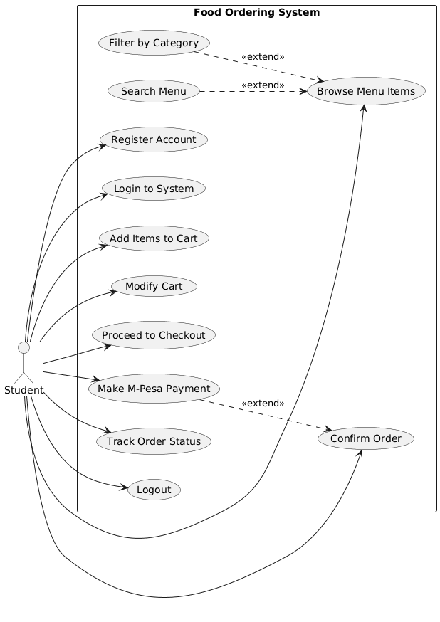
Figure 5.2 - Student Actor Use Case Diagram

Primary Student Use Cases
UC1: Register Account - Students create new accounts providing name, email, phone number, and password. System validates email format and phone number format, checks for duplicate emails, sends verification email, and creates user record in Firestore with initial loyalty points balance of zero.
UC2: Browse Menu and Place Order - Students view categorized menu items with images, descriptions, prices, and preparation times. They can search by name, filter by category (breakfast, lunch, snacks, beverages), and view detailed nutritional information if available. Selected items add to cart with quantity specification. Cart displays running total including any applied discounts from loyalty point redemption.
UC3: Checkout and Payment - Students review cart contents, specify pickup time preferences, enter special instructions (dietary restrictions, extra sauce requests), and select payment method. The system initiates M-Pesa STK Push sending payment prompt to student's phone. Upon payment authorization, the system creates order record, deducts loyalty points if applied, and displays confirmation with order tracking number.
UC4: Track Order Status - Students monitor order preparation progress through real-time status indicators: Order Received → Payment Confirmed → Preparing → Ready for Pickup → Completed. Push notifications alert students when status changes, particularly when orders are ready. The tracking interface shows estimated pickup time and current queue position if applicable.
UC5: Manage Loyalty Points - Students view current points balance, earn points automatically on order completion (calculated as 1 point per 100 KES spent), review points transaction history with dates and source orders, redeem accumulated points for discounts (100 points = 50 KES discount), and see points expiration dates if expiration policy is implemented.

Cafeteria Staff Use Cases
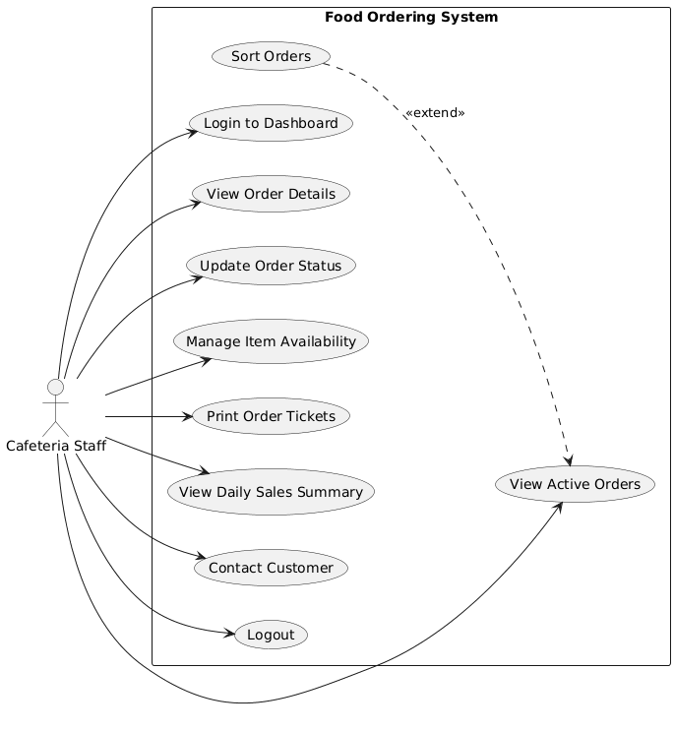
Figure 5.3 - Cafeteria Staff Actor Use Case Diagram

Primary Staff Use Cases
UC6: Manage Order Queue - Staff view all pending orders in chronological order or sorted by priority (scheduled pickup time, VIP customers). Each order displays customer name, items ordered, quantities, special instructions, payment status, and elapsed time since placement. Staff can expand orders to see full details including student contact information for clarification questions.
UC7: Update Order Status - Staff transition orders through preparation workflow with one-tap status updates. Changing status to "Preparing" removes order from pending queue and adds to active preparation list. Marking "Ready" triggers push notification to student and moves order to pickup area queue. Completing order archives it to history and triggers loyalty points calculation.
UC8: Manage Inventory Availability - Staff mark menu items as unavailable when ingredients run out, preventing new orders for those items. Items marked unavailable display greyed out in student app with "Currently Unavailable" messaging. Staff can re-enable items when inventory replenishes.
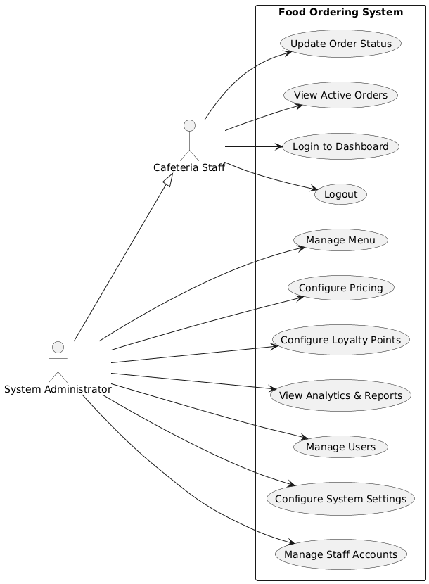
Figure 5.4 - System Administrator Use Case Diagram
Primary Administrator Use Cases
UC9: Manage Menu Items - Administrators have full CRUD operations on menu catalog. Creating items requires name, description, base price, category assignment, and image upload. Editing allows price adjustments, description updates, category changes, and image replacements. Deleting items performs soft delete (marks inactive) rather than hard delete to preserve historical order data referencing those items.
UC10: Configure Loyalty Program - Administrators adjust loyalty program parameters including points earning rate (default 1 point per 100 KES), redemption value (default 100 points = 50 KES), points expiration period if desired, bonus point multiplier events (double points day), and minimum purchase amount for points eligibility.
UC11: View Analytics - Administrators access comprehensive dashboards showing key performance indicators: total daily/weekly/monthly revenue, number of orders by time period, average order value, most popular menu items ranked by quantity sold, peak order hours for staffing optimization, loyalty program participation rate, and customer retention metrics.
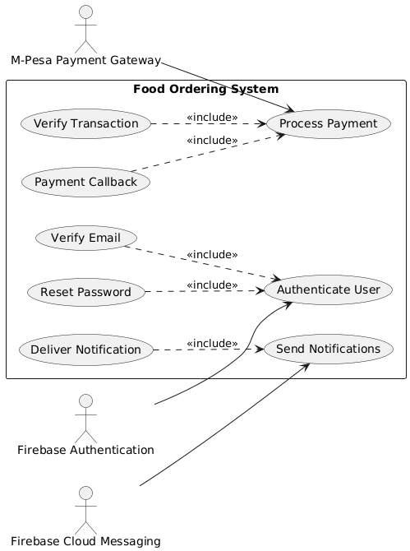
Figure 5.5 - External Systems Integration Use Case Diagram

External Integration Use Cases
UC12: Process M-Pesa Payment - When student confirms order, system generates payment request with transaction reference, amount, and customer phone number. Cloud Functions call M-Pesa Daraja API OAuth endpoint to obtain access token, then submit STK Push request. M-Pesa sends USSD payment prompt to student's phone. Student enters M-Pesa PIN authorizing payment. M-Pesa processes transaction and sends callback to system webhook with result code, transaction ID, and confirmation details.
UC13: Real-time Notifications - When staff update order status, Cloud Function triggers Firebase Cloud Messaging to send push notification to student's registered device. Notification includes order number, new status, and estimated pickup time. Student app receives notification even when backgrounded or closed, displaying system notification with sound/vibration based on device settings.

5.4 Activity Diagrams
Activity diagrams model the dynamic behavior of the system by illustrating workflows, business processes, and algorithmic logic including sequential activities, decision points, parallel processes, and control flow. These diagrams provide detailed insight into how specific use cases execute from start to completion, highlighting the procedural steps and conditional logic governing system operations.

User Registration and Login Workflow
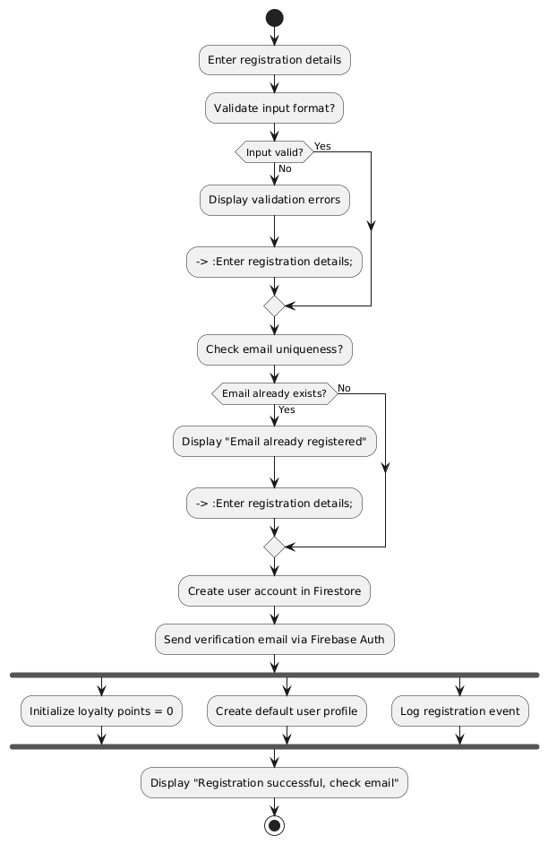
Figure 5.6 - User Registration Activity Diagram
The registration workflow implements comprehensive validation ensuring data quality and preventing duplicate accounts. Email format validation uses regex pattern matching, phone number validation confirms Kenyan format (+254 or 07xx), and password strength requirements enforce minimum 8 characters with at least one number. The email uniqueness check prevents users from creating multiple accounts with the same email, which could complicate order tracking and loyalty points management.
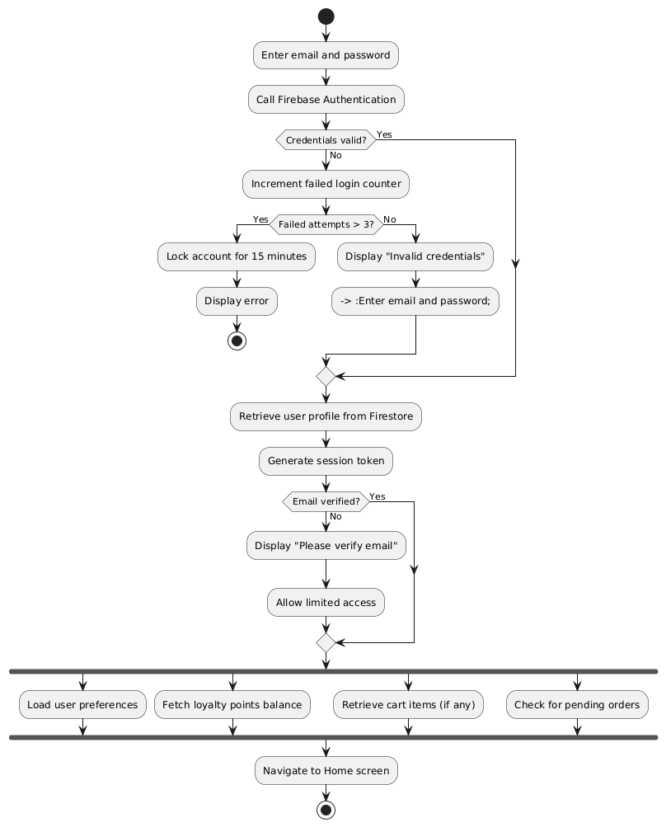
Figure 5.7 - User Login Activity Diagram
The login workflow includes security features like failed attempt limiting to prevent brute force attacks and email verification checking to ensure account authenticity. Session token generation uses Firebase Authentication's built-in JWT (JSON Web Token) mechanism, providing secure, stateless authentication suitable for mobile applications.

Order Placement Workflow
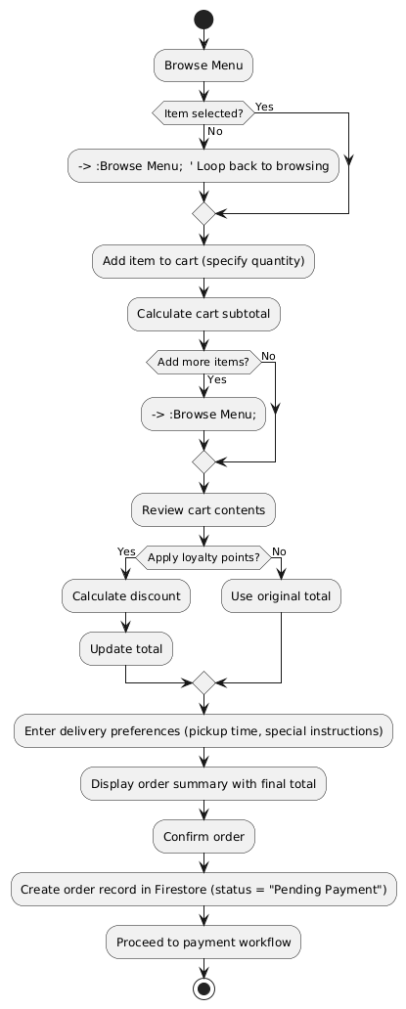
Figure 5.8 - Complete Order Placement Activity Diagram
This workflow demonstrates the shopping cart pattern common in e-commerce applications, adapted for food ordering context. The loyalty points decision point allows optional discount application without forcing users to redeem points on every order. The order creation before payment completion enables payment abandonment tracking—orders created but never paid indicate potential friction in the payment process.

M-Pesa Payment Processing Workflow
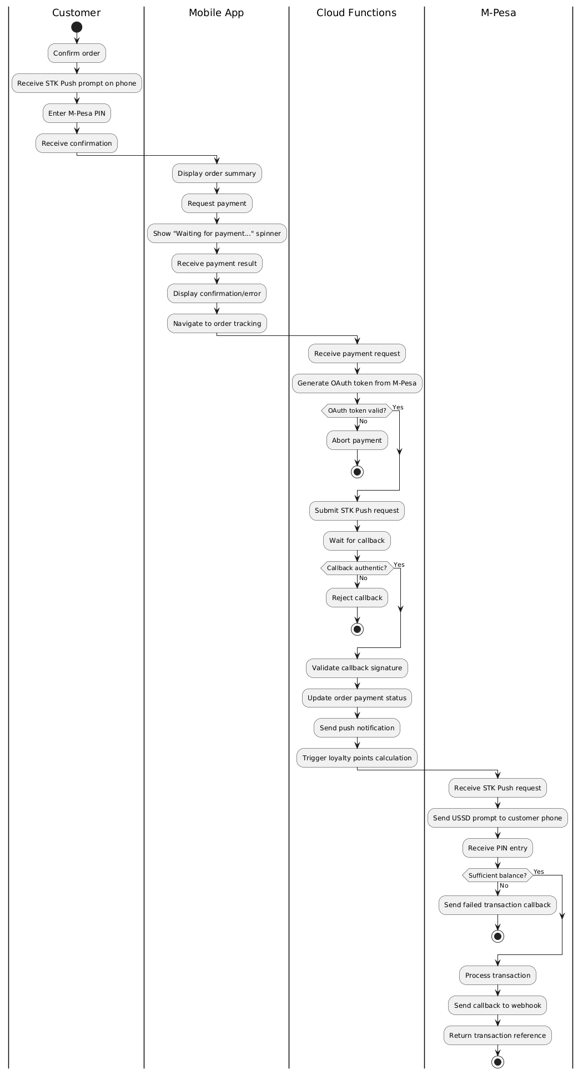
Figure 5.9 - M-Pesa Payment Processing Activity Diagram
The payment workflow involves complex interaction between multiple systems requiring careful orchestration. The STK Push mechanism provides better user experience than manual M-Pesa transfers by automatically prompting payment without users needing to remember paybill numbers or account numbers. Callback validation prevents fraudulent payment confirmation attempts—Cloud Functions verify callback requests originate from M-Pesa's IP addresses and contain valid signatures before updating order status.

Order Status Update Workflow
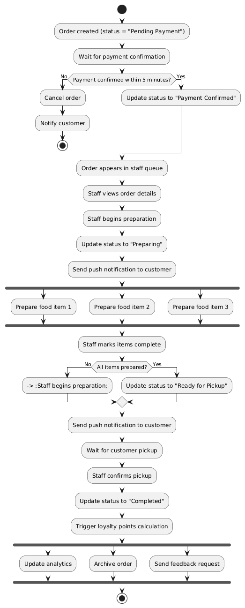
Figure 5.10 - Order Status Update Activity Diagram
This workflow models the order lifecycle from creation through completion, showing state transitions and notification triggers. The 5-minute payment timeout prevents unpaid orders from cluttering the queue. The parallel preparation activities recognize that kitchen staff can prepare multiple components simultaneously (cooking rice while grilling chicken), improving overall throughput.

Loyalty Points Calculation and Redemption Workflow
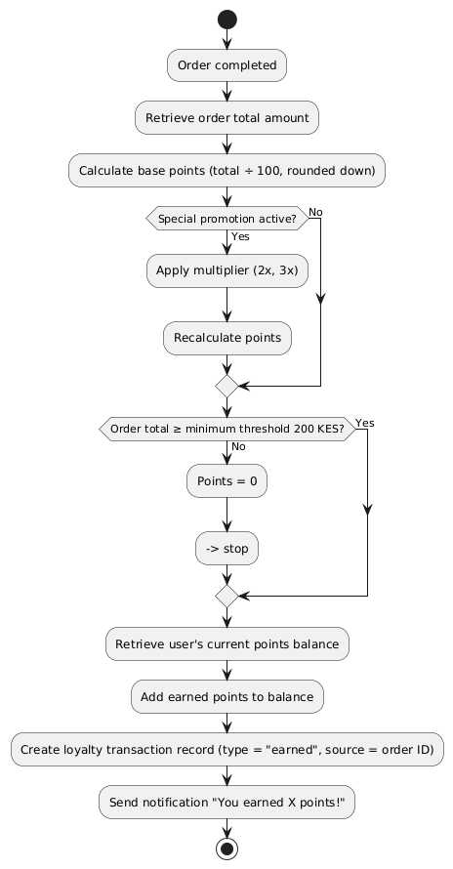
Figure 5.11 - Loyalty Points Calculation Activity Diagram
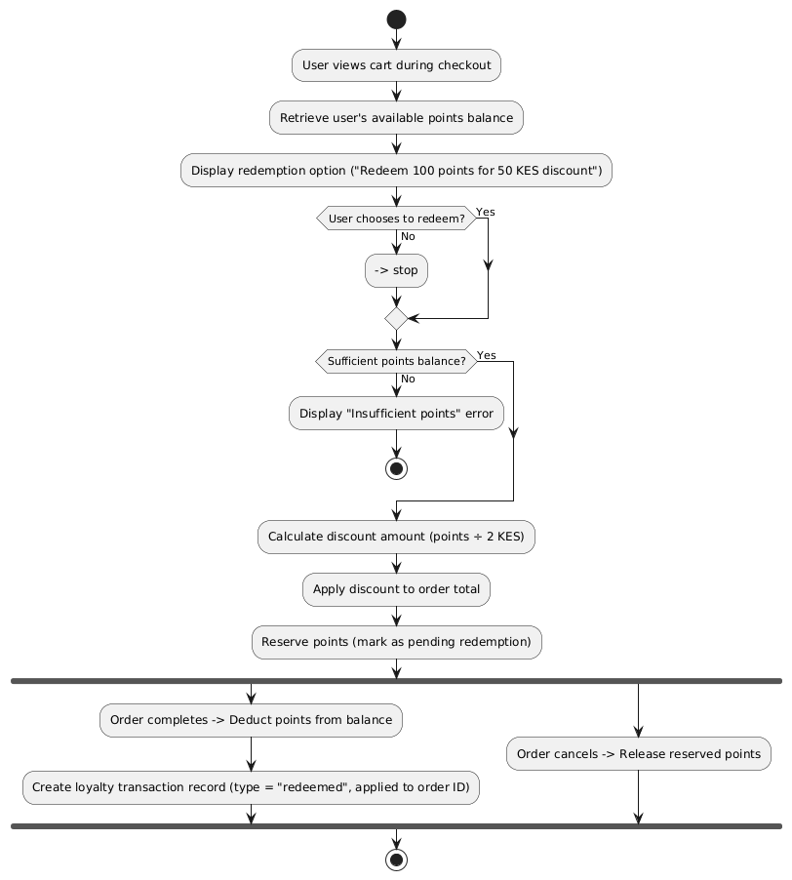
Figure 5.12 - Loyalty Points Redemption Activity Diagram
The loyalty program workflows implement a simple but effective points system: earn 1 point per 100 KES spent, redeem 100 points for 50 KES discount (50% value to encourage continued spending rather than immediate full-value redemption). The points reservation mechanism during checkout prevents race conditions where users might redeem the same points on multiple simultaneous orders.

5.5 Sequence Diagrams
Sequence diagrams illustrate object interactions arranged in time sequence, showing the order of messages exchanged between components to accomplish specific functionality. These diagrams emphasize the temporal ordering of operations and clearly delineate responsibilities across system components, making them particularly valuable for understanding complex multi-component interactions like payment processing and real-time synchronization.

User Authentication Sequence
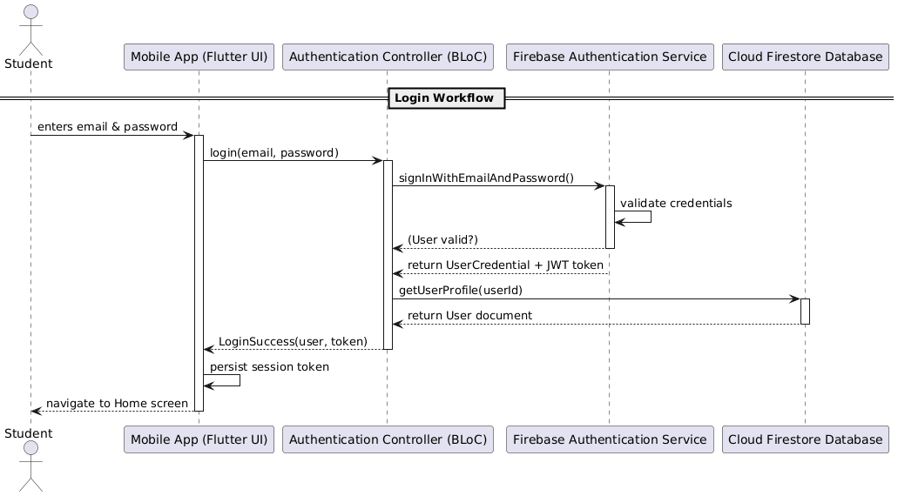
Figure 5.13 - User Login Sequence Diagram
The login sequence demonstrates the coordinated interaction between UI, business logic, authentication service, and database. The authentication controller acts as a mediator, preventing direct coupling between UI and Firebase services. The JWT token returned by Firebase Authentication persists in secure local storage, enabling automatic re-authentication on subsequent app launches without requiring password re-entry.

Order Placement and Payment Sequence
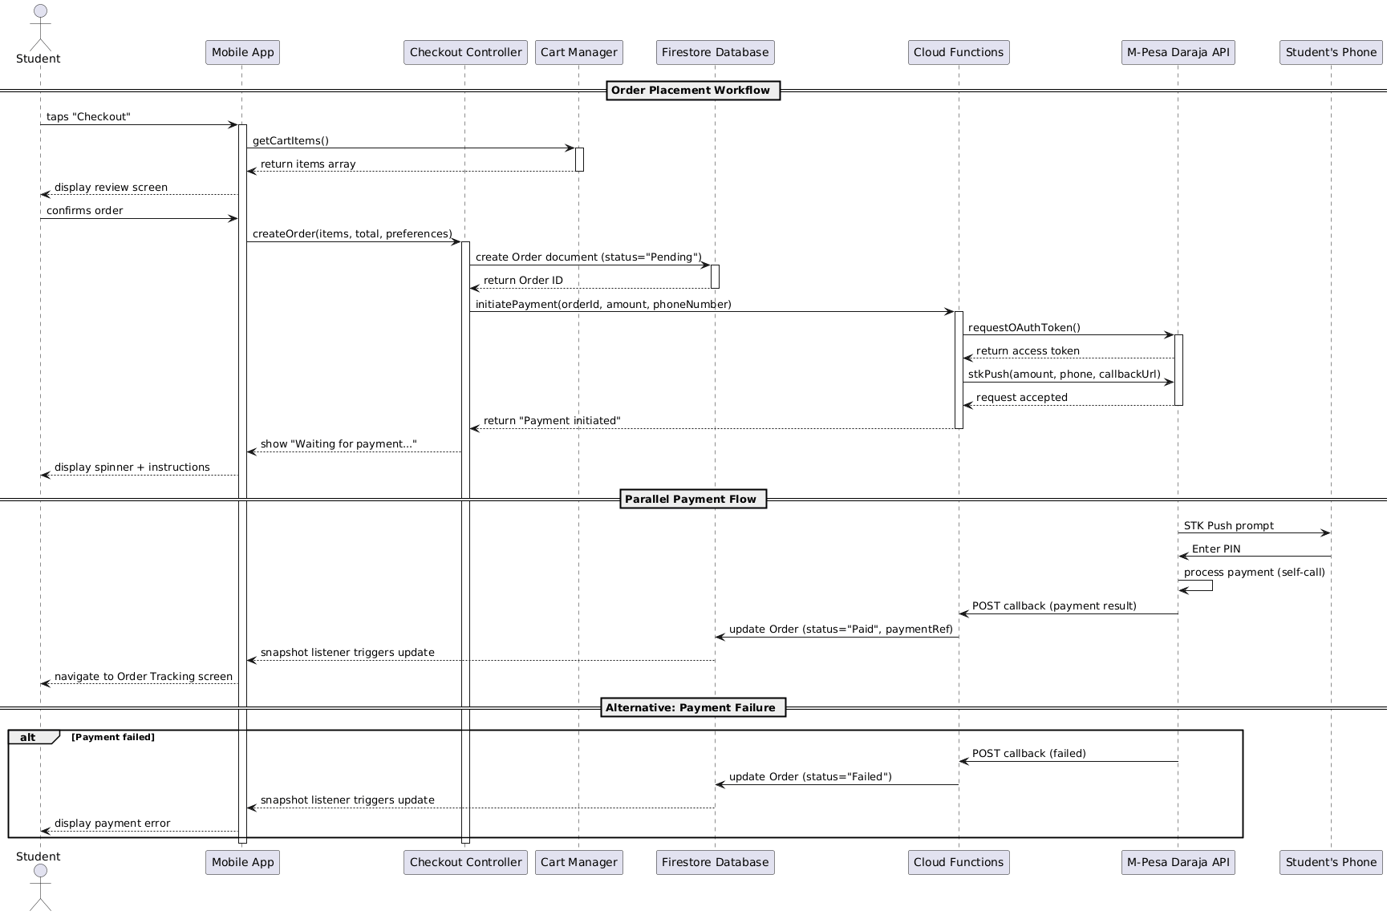
Figure 5.14 - Order Placement Sequence Diagram
This sequence illustrates the most complex workflow in the system, involving five distinct components. The asynchronous nature of M-Pesa payment requires careful state management—the app cannot block waiting for payment completion since users might take several minutes to authorize. The Firestore snapshot listener pattern enables reactive UI updates: when Cloud Functions update the order's payment status, the listener fires automatically updating the app's UI without polling.

Real-Time Order Tracking Sequence

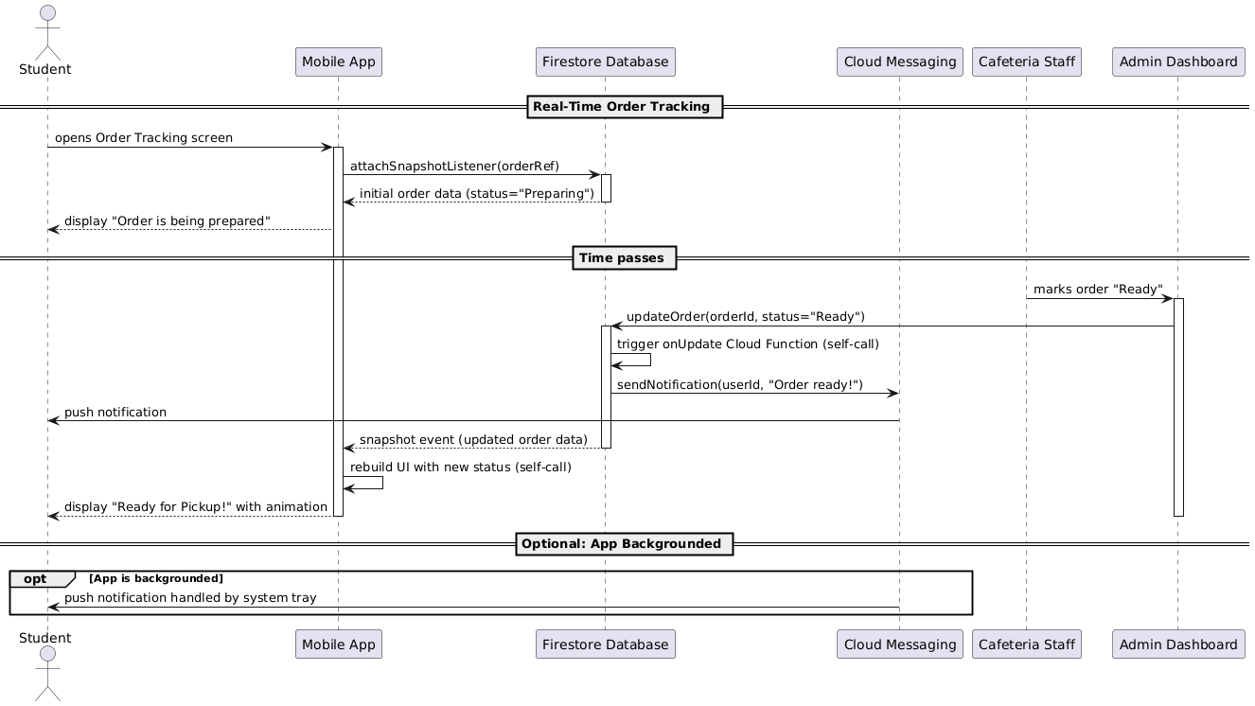
Figure 5.15 - Real-Time Order Tracking Sequence Diagram
The real-time tracking sequence showcases Firestore's live synchronization capabilities. The snapshot listener maintains an open WebSocket connection receiving instant updates when the order document changes. This eliminates the need for inefficient polling (repeatedly querying "has my order status changed?") reducing server load and battery consumption while providing superior user experience with instant updates.

Menu Loading and Caching Sequence
Figure 5.16 - Menu Loading with Cache Sequence Diagram
Sequence diagram demonstrating offline-first architecture:
- Lifelines: Student, Mobile App, Menu Controller, Local Cache (SQLite), Firestore Database
- Message sequence:
  - Student → Mobile App: launches app
  - Mobile App → Menu Controller: loadMenu()
  - Menu Controller → Local Cache: getMenuItems()
  - Local Cache → Menu Controller: return cached items (with timestamp)
  - Menu Controller → Mobile App: display cached menu immediately
  - Mobile App → Student: menu appears (instant, from cache)
  - [Parallel] Menu Controller → Firestore: queryMenuItems(since=lastCacheTime)
  - Firestore → Menu Controller: return updated items (if any)
  - Alt frame: "if updates exist"
    - Menu Controller → Local Cache: updateCache(newItems)
    - Local Cache → Menu Controller: cache updated
    - Menu Controller → Mobile App: notify UI refresh
    - Mobile App → Student: menu updates with fade animation
  - Alt frame: "if network unavailable"
  - Firestore → Menu Controller: connection error
  - Menu Controller → Mobile App: operate from cache only
  - Mobile App → Student: show "Offline mode" indicator
This sequence demonstrates the offline-first pattern improving perceived performance and reliability. Users see menu content instantly from cache rather than waiting for network requests. The parallel network fetch updates the cache in background without blocking UI rendering. This pattern ensures the app remains functional even without connectivity—users can browse menus and prepare carts offline, with synchronization occurring when connectivity resumes.

Loyalty Points Calculation Sequence
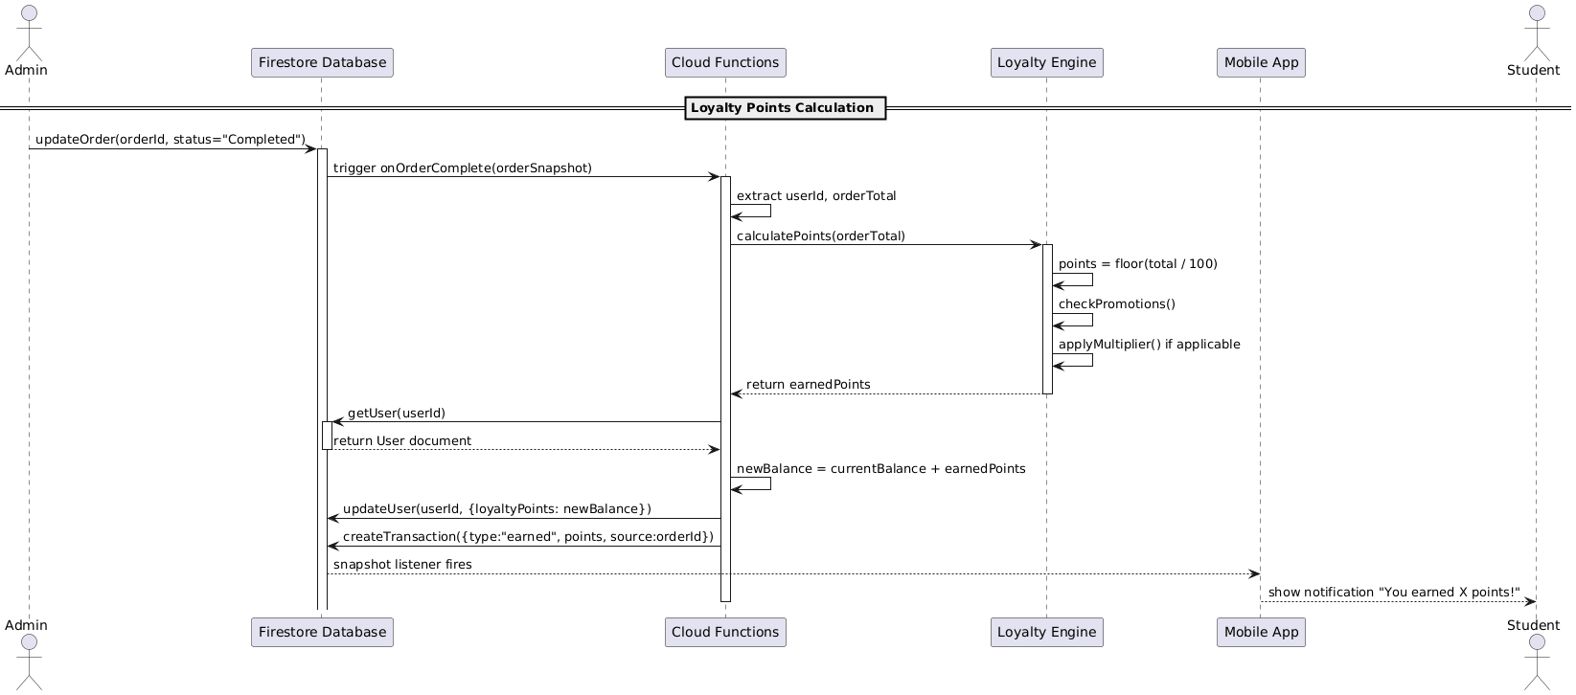
Figure 5.17 - Loyalty Points Calculation Sequence Diagram
This sequence illustrates server-side business logic execution via Cloud Functions. The Firestore trigger automatically invokes the function when an order status changes to "Completed", ensuring points calculation occurs reliably without requiring client-side code execution. Server-side calculation prevents client manipulation—users cannot modify code to award themselves arbitrary points.

5.6 Class Diagrams
Class diagrams represent the static structure of the system by modeling classes (object templates), their attributes (data), methods (behavior), and relationships (associations, dependencies, inheritance). While the system uses Firestore's document-based NoSQL database rather than traditional object-relational mapping, class diagrams remain valuable for modeling the application's domain objects, data transfer objects, and business logic components.

Core Domain Model
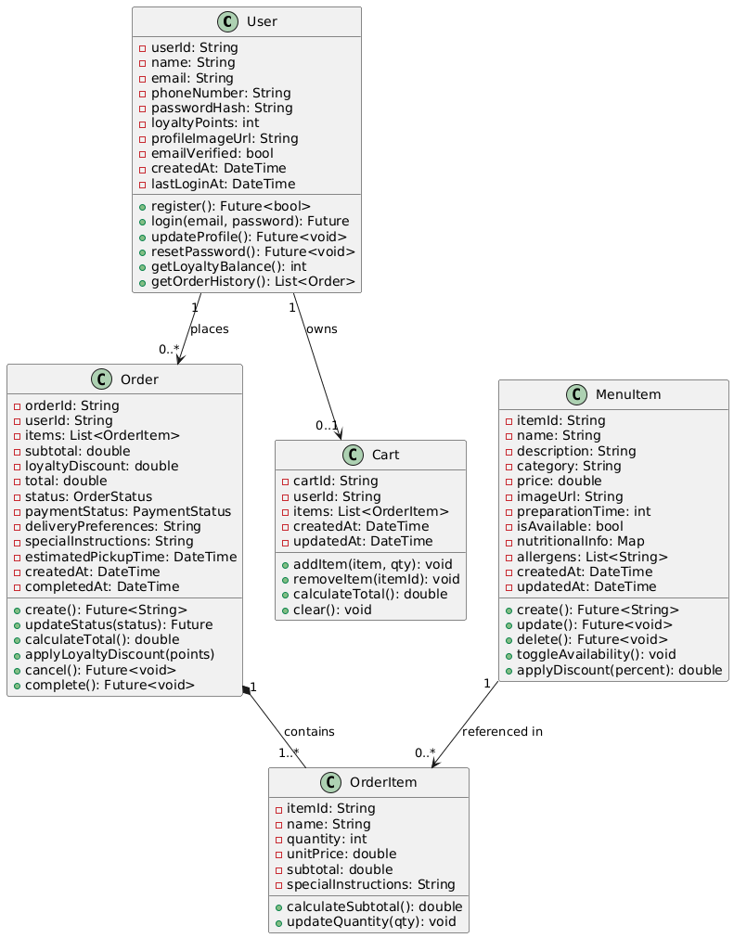
Figure 5.18 - Core Domain Classes Diagram

Payment and Transaction Classes
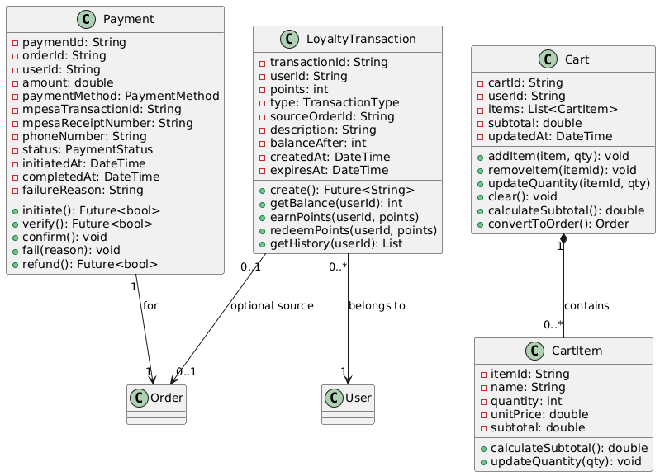
Figure 5.19 - Payment Domain Classes Diagram

Controller and Service Classes
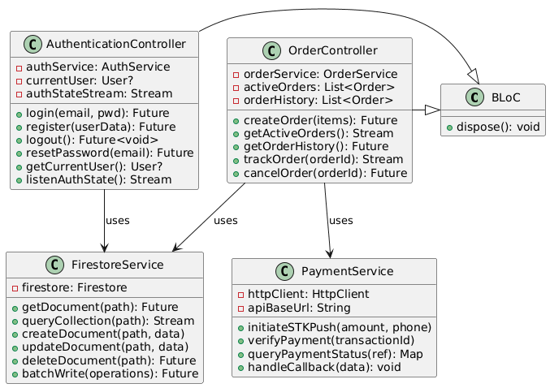
Figure 5.20 - Application Logic Classes Diagram]

Enumeration Types
The system defines several enumeration types ensuring type safety and preventing invalid state values:
OrderStatus Enumeration:
<<enumeration>>
OrderStatus
─────────────
PENDING_PAYMENT
PAYMENT_CONFIRMED
PREPARING
READY_FOR_PICKUP
COMPLETED
CANCELLED
PaymentStatus Enumeration:
<<enumeration>>
PaymentStatus
─────────────
INITIATED
PENDING
COMPLETED
FAILED
REFUNDED
PaymentMethod Enumeration:
<<enumeration>>
PaymentMethod
─────────────
MPESA
CASH
CARD (future)
TransactionType Enumeration:
<<enumeration>>
TransactionType
─────────────
EARNED
REDEEMED
EXPIRED
ADJUSTED
UserRole Enumeration:
<<enumeration>>
UserRole
─────────────
CUSTOMER
STAFF
ADMINISTRATOR
These enumerations prevent errors like setting order status to arbitrary strings ("almost done", "cooking") ensuring consistent state representation throughout the system. Firestore stores these as strings but application code enforces enum constraints.

Key Relationships and Patterns
The class structure implements several design patterns:
Repository Pattern: FirestoreService acts as a repository abstracting data access, allowing controller code to work with domain objects without coupling to Firestore-specific APIs. This enables easier testing (mock repository) and potential future database migration.
Singleton Pattern: Services (PaymentService, FirestoreService) implement singleton pattern ensuring single instances throughout app lifecycle, preventing redundant connections and maintaining consistent state.
Observer Pattern: BLoC controllers expose Streams that UI widgets observe for state changes, implementing reactive programming where UI automatically updates when underlying data changes.
Composition over Inheritance: OrderItem exists only within Order (composition relationship), never independently. When Order deletes, associated OrderItems delete automatically. This models real-world relationship—order items don't exist without parent order.

5.7 Database Schema
The system utilizes Cloud Firestore, a NoSQL document database, as its primary data store. Unlike traditional relational databases with fixed schemas enforced at the database level, Firestore employs a flexible document-oriented model where each document is a JSON-like object containing key-value pairs. Documents organize into collections, which can contain subcollections, enabling hierarchical data structures. While this flexibility allows schema evolution without migrations, careful schema design remains critical for performance, data consistency, and query efficiency.

Database Architecture Overview
[DIAGRAM PLACEHOLDER: Figure 5.21 - Firestore Database ER Diagram]
An entity-relationship diagram showing Firestore collections and their relationships:
- Top level: Users collection, MenuItems collection, Orders collection, Payments collection, LoyaltyTransactions collection
- Users collection containing user documents
- MenuItems collection containing menu item documents
- Orders collection containing order documents, with subcollection OrderItems
- Payments collection with references to Orders
- LoyaltyTransactions collection with references to Users
- Lines showing relationships with cardinality (1:N, 1:1)
- Foreign key references shown as dashed arrows labeled with field names (userId, orderId, etc.)

Collection Schemas

Users Collection
Path: /users/{userId}
The Users collection stores all registered user accounts with authentication details, profile information, and loyalty program data.
Document Structure:
{
"userId": "string (document ID, matches Firebase Auth UID)",
"name": "string (full name)",
"email": "string (unique, lowercase)",
"phoneNumber": "string (format: +254XXXXXXXXX)",
"profileImageUrl": "string (Cloud Storage URL, optional)",
"loyaltyPoints": "number (integer, default 0)",
"role": "string (enum: 'customer', 'staff', 'admin', default 'customer')",
"emailVerified": "boolean (from Firebase Auth)",
"accountStatus": "string (enum: 'active', 'suspended', 'deleted')",
"preferences": {
"notifications": "boolean",
"newsletter": "boolean",
"favoriteCategories": "array<string>"
},
"createdAt": "timestamp (Firestore serverTimestamp)",
"updatedAt": "timestamp",
"lastLoginAt": "timestamp"
}
Indexes:
- email (ascending) - for uniqueness checks during registration
- phoneNumber (ascending) - for duplicate prevention
- loyaltyPoints (descending) - for leaderboard queries (future feature)
Security Rules:
// Users can read only their own document
match /users/{userId} {
allow read: if request.auth.uid == userId;
allow create: if request.auth.uid == userId;
allow update: if request.auth.uid == userId &&
!request.resource.data.diff(resource.data).affectedKeys()
.hasAny(['loyaltyPoints', 'role']);
// Only admin can modify loyalty points and roles
}
Sample Document:
{
"userId": "abc123xyz",
"name": "John Kamau",
"email": "john.kamau@students.usiu.ac.ke",
"phoneNumber": "+254712345678",
"profileImageUrl": "https://storage.googleapis.com/...",
"loyaltyPoints": 250,
"role": "customer",
"emailVerified": true,
"accountStatus": "active",
"preferences": {
"notifications": true,
"newsletter": false,
"favoriteCategories": ["lunch", "beverages"]
},
"createdAt": "2026-01-15T09:30:00Z",
"updatedAt": "2026-01-28T14:20:00Z",
"lastLoginAt": "2026-01-29T08:15:00Z"
}

MenuItems Collection
Path: /menuItems/{itemId}
Stores the cafeteria's menu catalog with all available food and beverage items.
Document Structure:
{
"itemId": "string (auto-generated document ID)",
"name": "string (display name)",
"description": "string (detailed description)",
"category": "string (enum: 'breakfast', 'lunch', 'dinner', 'snacks', 'beverages')",
"price": "number (double, Kenya Shillings)",
"imageUrl": "string (Cloud Storage URL)",
"preparationTime": "number (integer, minutes)",
"isAvailable": "boolean (in stock)",
"isActive": "boolean (soft delete flag)",
"nutritionalInfo": {
"calories": "number (optional)",
"protein": "number (grams, optional)",
"carbs": "number (grams, optional)",
"fat": "number (grams, optional)"
},
"allergens": "array<string> (['peanuts', 'dairy', 'gluten', etc.])",
"tags": "array<string> (['vegetarian', 'vegan', 'spicy', 'popular'])",
"popularityScore": "number (calculated metric for sorting)",
"createdAt": "timestamp",
"updatedAt": "timestamp",
"createdBy": "string (admin userId)"
}
Indexes:
- category (ascending), isAvailable (ascending), name (ascending) - for category browsing
- isActive (ascending), popularityScore (descending) - for homepage popular items
- price (ascending) - for price range filtering
Sample Document:
{
"itemId": "item_chips_masala_001",
"name": "Chips Masala",
"description": "Golden crispy French fries tossed in aromatic masala spices with peppers and onions",
"category": "lunch",
"price": 150.00,
"imageUrl": "https://storage.googleapis.com/.../chips-masala.jpg",
"preparationTime": 15,
"isAvailable": true,
"isActive": true,
"nutritionalInfo": {
"calories": 420,
"protein": 6,
"carbs": 58,
"fat": 18
},
"allergens": [],
"tags": ["popular", "vegetarian", "spicy"],
"popularityScore": 87,
"createdAt": "2026-01-10T10:00:00Z",
"updatedAt": "2026-01-28T11:30:00Z",
"createdBy": "admin_001"
}

Orders Collection
Path: /orders/{orderId}
Contains all customer orders from placement through completion.
Document Structure:
{
"orderId": "string (auto-generated)",
"userId": "string (reference to Users collection)",
"userName": "string (denormalized for quick display)",
"userPhone": "string (denormalized for contact)",
"items": "array<object> (OrderItem objects)",
"subtotal": "number (before discounts)",
"loyaltyDiscount": "number (discount amount from redeemed points)",
"pointsRedeemed": "number (integer, points used)",
"total": "number (final amount after discounts)",
"status": "string (enum: 'pending_payment', 'paid', 'preparing', 'ready', 'completed', 'cancelled')",
"paymentStatus": "string (enum: 'pending', 'completed', 'failed')",
"paymentId": "string (reference to Payments collection)",
"deliveryPreferences": {
"pickupTime": "timestamp (requested pickup time)",
"specialInstructions": "string (optional)"
},
"estimatedReadyTime": "timestamp (calculated)",
"actualReadyTime": "timestamp (nullable)",
"createdAt": "timestamp",
"updatedAt": "timestamp",
"completedAt": "timestamp (nullable)"
}
Items Array Structure:
{
"itemId": "string (reference to MenuItem)",
"name": "string (denormalized)",
"quantity": "number (integer)",
"unitPrice": "number (price at time of order)",
"subtotal": "number (quantity × unitPrice)",
"specialInstructions": "string (optional, e.g., 'no onions')"
}
Indexes:
- userId (ascending), createdAt (descending) - for user order history
- status (ascending), createdAt (ascending) - for staff queue display
- createdAt (descending) - for recent orders analytics
Sample Document:
{
"orderId": "order_20260129_001",
"userId": "abc123xyz",
"userName": "John Kamau",
"userPhone": "+254712345678",
"items": [
{
"itemId": "item_chips_masala_001",
"name": "Chips Masala",
"quantity": 1,
"unitPrice": 150.00,
"subtotal": 150.00,
"specialInstructions": "Extra spicy"
},
{
"itemId": "item_soda_cola_500",
"name": "Coca-Cola 500ml",
"quantity": 1,
"unitPrice": 80.00,
"subtotal": 80.00,
"specialInstructions": ""
}
],
"subtotal": 230.00,
"loyaltyDiscount": 50.00,
"pointsRedeemed": 100,
"total": 180.00,
"status": "preparing",
"paymentStatus": "completed",
"paymentId": "pay_mpesa_abc123",
"deliveryPreferences": {
"pickupTime": "2026-01-29T13:00:00Z",
"specialInstructions": "Please call when ready"
},
"estimatedReadyTime": "2026-01-29T12:55:00Z",
"actualReadyTime": null,
"createdAt": "2026-01-29T12:30:00Z",
"updatedAt": "2026-01-29T12:35:00Z",
"completedAt": null
}

Payments Collection
Path: /payments/{paymentId}
Records all payment transactions with M-Pesa integration details.
Document Structure:
{
"paymentId": "string (auto-generated)",
"orderId": "string (reference to Orders)",
"userId": "string (reference to Users)",
"amount": "number (transaction amount)",
"paymentMethod": "string (enum: 'mpesa', 'cash')",
"phoneNumber": "string (M-Pesa phone number)",
"mpesaCheckoutRequestId": "string (from STK Push)",
"mpesaTransactionId": "string (from callback)",
"mpesaReceiptNumber": "string (M-Pesa confirmation code)",
"status": "string (enum: 'initiated', 'pending', 'completed', 'failed', 'refunded')",
"failureReason": "string (nullable, error details)",
"initiatedAt": "timestamp",
"completedAt": "timestamp (nullable)",
"callbackData": "object (raw M-Pesa callback for debugging)"
}
Sample Document:
{
"paymentId": "pay_mpesa_abc123",
"orderId": "order_20260129_001",
"userId": "abc123xyz",
"amount": 180.00,
"paymentMethod": "mpesa",
"phoneNumber": "+254712345678",
"mpesaCheckoutRequestId": "ws_CO_29012026123045678",
"mpesaTransactionId": "OBK1ABC2XY",
"mpesaReceiptNumber": "OBK1ABC2XY",
"status": "completed",
"failureReason": null,
"initiatedAt": "2026-01-29T12:30:30Z",
"completedAt": "2026-01-29T12:30:55Z",
"callbackData": { /* M-Pesa callback JSON */ }
}

LoyaltyTransactions Collection
Path: /loyaltyTransactions/{transactionId}
Audit trail of all loyalty points earned and redeemed.
Document Structure:
{
"transactionId": "string (auto-generated)",
"userId": "string (reference to Users)",
"points": "number (integer, positive for earned, negative for redeemed)",
"type": "string (enum: 'earned', 'redeemed', 'expired', 'adjusted')",
"sourceOrderId": "string (nullable, reference to Orders if applicable)",
"description": "string (human-readable explanation)",
"balanceBefore": "number (user's balance before transaction)",
"balanceAfter": "number (user's balance after transaction)",
"createdAt": "timestamp",
"expiresAt": "timestamp (nullable, for earned points with expiration)"
}
Sample Document:
{
"transactionId": "loyalty_tx_12345",
"userId": "abc123xyz",
"points": -100,
"type": "redeemed",
"sourceOrderId": "order_20260129_001",
"description": "Redeemed 100 points for 50 KES discount on Order #order_20260129_001",
"balanceBefore": 250,
"balanceAfter": 150,
"createdAt": "2026-01-29T12:30:25Z",
"expiresAt": null
}

Data Relationships and Integrity
Firestore does not enforce foreign key constraints at the database level, so the application code must maintain referential integrity:
- Users ↔ Orders: One-to-many. Orders contain userId field. Application validates user exists before creating order.
- Orders ↔ Payments: One-to-one. Payment contains orderId reference. orders contain paymentId back-reference for quick lookup.
- Orders ↔ MenuItems: Many-to-many (through items array). Items array denormalizes item names and prices to preserve historical order data even if menu items change.
- Users ↔ LoyaltyTransactions: One-to-many. Transactions contain userId. Cloud Functions ensure atomic points balance updates.
Denormalization Strategy: The schema denormalizes frequently-accessed data (user names in orders, item names in order items) to minimize complex joins and improve query performance. This trades storage space for read performance—a common NoSQL pattern.

5.8 UI Design
User interface design represents a critical determinant of application success—even perfectly functional systems fail if users find interfaces confusing, unattractive, or frustrating. This section presents the UI/UX design for the Cafeteria Ordering and Loyalty Reward System, including wireframes establishing structural layout, high-fidelity mockups demonstrating visual design, and design rationale explaining choices. The design follows platform-specific guidelines (Material Design for Android, iOS Human Interface Guidelines) while maintaining brand consistency across platforms.

Design Philosophy and Principles
The UI design centers on five core principles:
- Simplicity: Minimize cognitive load by presenting only essential information at each step, using progressive disclosure to reveal complexity only when needed
- Speed: Optimize for task completion velocity—students should browse menus and place orders in under 90 seconds
- Clarity: Use clear visual hierarchy, readable typography, and unambiguous iconography eliminating guesswork
- Consistency: Maintain uniform interaction patterns, visual language, and terminology throughout the app
- Delight: Include subtle animations, smooth transitions, and encouraging feedback creating emotionally positive experiences

Color Palette
The application employs a vibrant, appetite-stimulating color scheme balanced with neutral tones for readability:
Primary Colors:
- Orange (#FF6B35) - Primary brand color, used for CTAs, active states, conveys energy and appetite
- Deep Orange (#E94B3C) - Darker variant for pressed states, shadows
- Coral (#FFA07A) - Lighter tint for backgrounds, highlights
Secondary Colors:
- Teal (#2A9D8F) - Secondary accent, used for success states, loyalty features
- Navy Blue (#264653) - Dark neutral for text, headers
Neutral Palette:
- White (#FFFFFF) - Backgrounds, cards
- Light Gray (#F4F4F4) - Subtle backgrounds, disabled states
- Medium Gray (#BFBFBF) - Borders, dividers
- Dark Gray (#404040) - Body text
Semantic Colors:
- Success Green (#4CAF50) - Confirmation messages, completed orders
- Warning Amber (#FFC107) - Pending states, warnings
- Error Red (#F44336) - Errors, cancellations

Typography
Primary Font: Inter (Google Font)
Rationale: Excellent readability at all sizes, extensive weight options (Thin to Black), optimized for screens, modern geometric sans-serif aesthetic
Type Scale:
- H1 Headlines: Inter Bold, 28pt - Screen titles
- H2 Section Headers: Inter SemiBold, 22pt - Section dividers
- H3 Card Titles: Inter SemiBold, 18pt - Menu item names, card headers
- Body Text: Inter Regular, 16pt - Descriptions, labels
- Small Text: Inter Regular, 14pt - Metadata, timestamps
- Caption: Inter Medium, 12pt - Hints, footnotes
- Button Text: Inter SemiBold, 16pt - All buttons

UI Wireframes
Wireframes provide low-fidelity structural blueprints showing layout, navigation, and content hierarchy without visual design details.
[DIAGRAM PLACEHOLDER: Figure 5.22 - Splash and Authentication Screens Wireframes]
Three wireframe screens showing:
Splash Screen:
- App logo centered
- Loading indicator below
- "Cafeteria Ordering System" text
Login Screen:
- Top: Logo and "Welcome Back" heading
- Email input field
- Password input field with visibility toggle
- "Forgot Password?" link (right-aligned)
- "Login" button (full width, prominent)
- "Don't have an account? Register" link (bottom, centered)
Registration Screen:
- "Create Account" heading
- Full Name input field
- Email input field
- Phone Number input field (+254 prefix shown)
- Password input field with strength indicator
- Confirm Password input field
- "I agree to Terms & Conditions" checkbox
- "Register" button
- "Already have account? Login" link
[DIAGRAM PLACEHOLDER: Figure 5.23 - Home and Menu Browsing Wireframes]
Four wireframe screens:
Home Screen:
- Top: Search bar with magnifying glass icon
- Below: Horizontal scrolling category chips (All, Breakfast, Lunch, Dinner, Snacks, Beverages)
- "Popular Items" section with 3 featured items in horizontal scroll (image + name + price)
- "All Menu Items" section with vertical grid of items (2 columns)
- Each item card: Square image on top, item name, price, "Add to Cart" button
- Bottom: Navigation bar (Home, Orders, Loyalty, Profile) with icons
Menu Item Detail Screen:
- Top: Full-width item image
- Back button (top-left)
- Favorite button (top-right, heart icon)
- Item name (large heading)
- Price (prominent, below name)
- Star rating + review count
- Description paragraph
- "Preparation time: 15 mins" with clock icon
- Allergen tags (if applicable)
- Quantity selector (- button, number, + button)
- "Add to Cart" button (full width, sticky at bottom)
Shopping Cart Screen:
- "My Cart" heading
- Cart items list:
  - Each item: thumbnail image, name, price, quantity selector, remove icon
  - Subtotal shown per item
- "Apply Loyalty Points" expandable section showing available points and redemption option
- Summary section: Subtotal, Discount (if applied), Total (bold, large)
- "Proceed to Checkout" button
- "Continue Shopping" link
Search and Filter Screen:
- Search input at top with real-time results
- Filter chips: Price Range, Category, Dietary (Vegetarian, Vegan)
- Results count: "24 items found"
- Results grid (same format as home screen)
- "Clear Filters" option
[DIAGRAM PLACEHOLDER: Figure 5.24 - Checkout and Payment Wireframes]
Three wireframe screens:
Checkout Screen:
- Order summary (collapsed item list with expand option)
- Pickup time selector (Now, 30 min, 1 hour, Custom)
- Special instructions text area
- Order details review:
  - Items count
  - Subtotal
  - Loyalty discount (if any)
  - Total (bold)
- Payment method selection (M-Pesa selected by default)
- "Confirm Order" button
Payment Processing Screen:
- Progress indicator (spinner)
- "Processing Payment..." heading
- "Check your phone for M-Pesa prompt" instruction
- M-Pesa icon with pulsing animation
- Order summary sidebar (fixed)
- "Cancel" button (secondary, bottom)
Order Confirmation Screen:
- Success checkmark animation (large, centered)
- "Order Confirmed!" heading
- Order number (e.g., "#ORD-20260129-001")
- Estimated pickup time
- "Track Order" button
- "View Receipt" button (secondary)
- "Back to Home" link
[DIAGRAM PLACEHOLDER: Figure 5.25 - Order Tracking and History Wireframes]
Four wireframe screens:
Order Tracking Screen:
- Order number heading
- Progress stepper showing:
  - Payment Confirmed (completed, checkmark)
  - Preparing (current, pulsing)
  - Ready for Pickup (pending)
  - Completed (pending)
- Estimated ready time countdown: "Ready in ~12 minutes"
- Order details (expandable):
  - Items list
  - Total paid
  - Pickup location
- "Contact Cafeteria" button
- "Cancel Order" button (if status allows)
Active Orders Screen:
- "Active Orders" heading
- List of current orders (if multiple):
  - Each card: Order #, Status badge, Items preview, Time remaining
  - Tap to expand to full tracking
- Empty state if no orders: "No active orders" with illustration
Order History Screen:
- "Order History" heading
- Filter: Last 30 days, Last 3 months, All time
- Chronological list of past orders:
  - Each card: Date, Items summary, Total, Status (Completed/Cancelled)
  - "Reorder" button
  - "View Details" link
- Pagination or infinite scroll
Order Detail History Screen:
- Full order information:
  - Order date and time
  - Items with quantities and prices
  - Payment method and transaction ID
  - Final total
- "Reorder These Items" button
- "Download Receipt" option
[DIAGRAM PLACEHOLDER: Figure 5.26 - Loyalty Program and Profile Wireframes]
Four wireframe screens:
Loyalty Points Screen:
- Large points balance display (circular progress indicator showing points balance out of next reward milestone)
- "You have 250 points" heading
- "Earn 2 points for every 100 KES spent" explanation
- Redemption value: "100 points = 50 KES discount"
- "Redeem Points" button
- Points history timeline:
  - Each entry: Date, Description ("Earned from Order #123"), Points (+20), Balance
- "Points expire in 365 days" notice
Profile Screen:
- Profile photo (circular, with edit icon)
- Name
- Email
- Phone number
- "Edit Profile" button
- Settings sections:
  - Notifications (toggle)
  - Newsletter subscription (toggle)
  - Language preference
  - Terms & Conditions link
  - Privacy Policy link
- "Change Password"
- "Logout" (destructive action)
Edit Profile Screen:
- Fields: Name, Email (disabled), Phone, Profile photo upload
- "Save Changes" button
- "Cancel" link
Admin Dashboard (Web) - Order Queue:
- Sidebar navigation: Orders, Menu, Analytics, Users
- Main area: "Active Orders" table
  - Columns: Order #, Customer, Items, Total, Time Elapsed, Status, Actions
  - Status dropdown for each order (Preparing, Ready, Completed)
  - Auto-refresh every 30 seconds
- Filter: Show All / Show Pending / Show Preparing
- Sound notification for new orders
[DIAGRAM PLACEHOLDER: Figure 5.27 - Admin Dashboard Wireframes]
Three wireframe screens for web dashboard:
Admin Menu Management:
- "Menu Items" heading
- "Add New Item" button (top-right)
- Items table: Image, Name, Category, Price, Status (Available/Unavailable), Actions (Edit/Delete)
- Toggle availability button for each item
Admin Analytics Dashboard:
- KPI Cards row:
  - Today's Orders (count)
  - Today's Revenue (KES)
  - Active Users
  - Average Order Value
- Line chart: Revenue over last 7 days
- Bar chart: Orders by hour (identify peak times)
- Pie chart: Revenue by category
- "Top 10 Popular Items" ranked list

High-Fidelity Mockups
High-fidelity mockups apply the visual design system to key screens, demonstrating final appearance.
[DIAGRAM PLACEHOLDER: Figure 5.28 - Home Screen High-Fidelity Mockup]
Full-color mockup of home screen showing:
- White background
- Orange accent color on "Add to Cart" buttons
- High-quality food photography for menu items
- Inter font applied to all text
- Drop shadows on cards for depth
- Active category chip with orange background
- Bottom navigation with icons and labels, active tab in orange
[DIAGRAM PLACEHOLDER: Figure 5.29 - Menu Item Detail High-Fidelity Mockup]
Detailed mockup showing:
- Full-bleed food photo at top with gradient overlay for text readability
- Back button as white circle with drop shadow
- Orange "Add to Cart" button with subtle gradient
- Quantity selector with rounded borders
- Tag chips for allergens/dietary info in neutral gray
- Smooth corner radius (12px) on all cards and buttons
[DIAGRAM PLACEHOLDER: Figure 5.30 - Order Tracking High-Fidelity Mockup]
Mockup demonstrating:
- Progress stepper with orange fill for completed steps
- Pulsing animation on current step
- Countdown timer in large, bold orange text
- Success green checkmarks on completed stages
- Teal "Contact Cafeteria" button
[DIAGRAM PLACEHOLDER: Figure 5.31 - Loyalty Points High-Fidelity Mockup]
Mockup showing:
- Circular progress indicator with orange fill
- Points balance in center (large numbers)
- Teal accent color for loyalty features
- Timeline using vertical line with circular markers
- Earned points in green, redeemed in gray
[DIAGRAM PLACEHOLDER: Figure 5.32 - Admin Dashboard High-Fidelity Mockup]
Web dashboard mockup with:
- Clean, professional interface
- Sidebar navigation with icons
- Data tables with alternating row colors
- Status badges (green for Ready, orange for Preparing)
- Charts using consistent color palette

Navigation Flow
[DIAGRAM PLACEHOLDER: Figure 5.33 - App Navigation Flow Diagram]
A flowchart showing screen-to-screen navigation:
- Splash → Login/Register → Home
- Home → Menu Detail → Cart → Checkout → Payment → Confirmation → Tracking
- Home → Search → Results → Menu Detail
- Bottom Nav: Home, Orders, Loyalty, Profile (accessible from any screen)
- Orders → Order Detail → Tracking
- Profile → Edit Profile, Settings, Logout

Design Rationale
Food Photography Emphasis: High-quality images drive appetite and purchase decisions. Full-bleed photos on detail screens maximize visual impact.
One-Tap Actions: "Add to Cart" buttons directly on home screen enable impulse purchases without navigation friction.
Progress Visibility: Real-time order tracking with visual progress indicators reduces anxiety and support requests.
Color Psychology: Orange stimulates appetite and creates urgency (encouraging orders), while teal provides calming balance for loyalty/account sections.
Minimal Form Fields: Registration requires only essential information (name, email, phone, password) reducing abandonment.
Sticky CTAs: Primary action buttons ("Add to Cart", "Proceed to Checkout") remain visible while scrolling, preventing users from forgetting to complete actions.

5.9 Requirements Specification
The requirements specification formalizes all functional and non-functional requirements guiding system development and providing measurable criteria for acceptance testing. Requirements are categorized, assigned unique identifiers for traceability, and prioritized using the MoSCoW method (Must have, Should have, Could have, Won't have). This structured approach ensures comprehensive coverage of system capabilities while maintaining clear scope boundaries preventing feature creep.

Functional Requirements
Functional requirements define specific behaviors and features the system must provide. Each requirement is stated as "The system shall..." to emphasize obligation rather than aspiration.

Authentication and User Management (FR1-FR5)
FR1: User Registration
Priority: Must Have
Description: The system shall allow new users to register accounts by providing name, email, phone number, and password. The system shall validate email format uniqueness, phone number format (+254 Kenyan format), and password strength (minimum 8 characters with at least one number). Upon successful registration, the system shall send email verification and create user record with zero initial loyalty points.
FR2: User Login
Priority: Must Have
Description: The system shall authenticate users via email and password using Firebase Authentication. The system shall validate credentials, generate JWT session tokens, and persist login state across app restarts. The system shall limit failed login attempts to 3 consecutive failures before implementing 15-minute account lockout.
FR3: Password Reset
Priority: Must Have
Description: The system shall provide password reset functionality via email. When users request password reset, the system shall send a secure reset link to the registered email address that expires after 1 hour.
FR4: Profile Management
Priority: Should Have
Description: The system shall allow users to view and edit profile information including name, phone number, and profile photo. The system shall prevent email address changes to maintain account integrity. The system shall allow password changes with current password verification.
FR5: Session Management
Priority: Must Have
Description: The system shall automatically log out users after 30 days of inactivity. The system shall provide manual logout functionality. Upon logout, the system shall clear session tokens and navigate to login screen.

Menu Browsing and Discovery (FR6-FR11)
FR6: Menu Display
Priority: Must Have
Description: The system shall display all available menu items with name, description, image, price, and preparation time. The system shall organize items by categories (breakfast, lunch, dinner, snacks, beverages). The system shall mark unavailable items clearly and prevent their ordering.
FR7: Menu Search
Priority: Should Have
Description: The system shall provide keyword search functionality across menu item names and descriptions. The system shall display search results in real-time as users type. The system shall highlight matching text in results.
FR8: Category Filtering
Priority: Must Have
Description: The system shall allow filtering menu items by category using horizontal scrolling category chips. The system shall visually indicate active filter. The system shall display item count for each category.
FR9: Item Detail View
Priority: Must Have
Description: The system shall display detailed information for selected menu items including full-size image, complete description, nutritional information (if available), allergen warnings, preparation time, and current availability status.
FR10: Popular Items
Priority: Should Have
Description: The system shall display a "Popular Items" section on the home screen showing the top 5 most frequently ordered items based on order history.
FR11: Item Favorites
Priority: Could Have
Description: The system shall allow users to mark menu items as favorites for quick access. The system shall display favorites in a dedicated section.

Shopping Cart and Ordering (FR12-FR18)
FR12: Add to Cart
Priority: Must Have
Description: The system shall allow users to add menu items to cart specifying quantity. The system shall support quantity adjustments (increment/decrement). The system shall prevent adding unavailable items. The system shall calculate and display cart subtotal in real-time.
FR13: Cart Management
Priority: Must Have
Description: The system shall allow users to view cart contents, modify item quantities, remove items, and clear entire cart. The system shall persist cart contents across app restarts. The system shall automatically remove items marked unavailable since addition.
FR14: Loyalty Points Redemption
Priority: Must Have
Description: During checkout, the system shall display user's available loyalty points and offer redemption option (100 points = 50 KES discount). The system shall allow partial point redemption in 100-point increments. The system shall apply discount to order total and reserve redeemed points pending payment confirmation.
FR15: Delivery Preferences
Priority: Should Have
Description: The system shall allow users to specify pickup time (now, 30 minutes, 1 hour, or custom time). The system shall accept special instructions text (maximum 500 characters) for dietary restrictions or customization requests.
FR16: Order Review
Priority: Must Have
Description: Before payment, the system shall display complete order summary including all items, quantities, prices, subtotal, loyalty discount (if applied), and final total. The system shall require explicit user confirmation before proceeding to payment.
FR17: Order Placement
Priority: Must Have
Description: Upon confirmation, the system shall create order record in Firestore with status "Pending Payment". The system shall generate unique order ID. The system shall store all order details including timestamp, user information, and delivery preferences.
FR18: Reordering
Priority: Could Have
Description: The system shall allow users to reorder complete previous orders with one tap. The system shall add all items from historical order to current cart. The system shall verify all items remain available before allowing reorder.

Payment Processing (FR19-FR22)
FR19: M-Pesa Integration
Priority: Must Have
Description: The system shall integrate M-Pesa Daraja API for payment processing. The system shall initiate STK Push sending payment prompt to user's registered phone number. The system shall support payment amounts from 10 KES to 50,000 KES.
FR20: Payment Verification
Priority: Must Have
Description: The system shall verify payment completion via M-Pesa callback. The system shall validate callback authenticity using signature verification. Upon successful payment, the system shall update order status to "Payment Confirmed" and release reserved loyalty points.
FR21: Payment Timeout
Priority: Must Have
Description: If payment does not complete within 5 minutes of order creation, the system shall automatically cancel the order and notify the user. The system shall release reserved loyalty points back to user balance.
FR22: Payment Receipt
Priority: Should Have
Description: The system shall display payment confirmation with M-Pesa transaction ID and receipt number. The system shall store payment records for user reference and admin reconciliation.

Order Tracking (FR23-FR26)
FR23: Real-Time Status Updates
Priority: Must Have
Description: The system shall provide real-time order status tracking using Firestore snapshot listeners. The system shall display current status (Payment Confirmed → Preparing → Ready for Pickup → Completed) with visual progress indicator. The system shall show estimated ready time.
FR24: Push Notifications
Priority: Must Have
Description: The system shall send push notifications when order status changes, particularly when orders become ready for pickup. Notifications shall include order number and new status.
FR25: Order History
Priority: Must Have
Description: The system shall maintain complete order history for each user. The system shall display past orders chronologically with date, items, total, and final status. The system shall allow viewing detailed information for historical orders.
FR26: Order Cancellation
Priority: Should Have
Description: The system shall allow users to cancel orders if status is "Pending Payment" or "Payment Confirmed" (not yet preparing). The system shall refund payment if applicable and release reserved loyalty points.

Loyalty Program (FR27-FR29)
FR27: Points Earning
Priority: Must Have
Description: The system shall automatically calculate and award loyalty points upon order completion. The system shall award 1 point per 100 KES spent (rounded down). The system shall apply promotional multipliers (2x, 3x points) when active. The system shall enforce minimum purchase threshold of 200 KES for points eligibility.
FR28: Points Balance Display
Priority: Must Have
Description: The system shall display user's current loyalty points balance on profile screen and during checkout. The system shall show redemption value (100 points = 50 KES discount).
FR29: Points Transaction History
Priority: Should Have
Description: The system shall maintain complete transaction history showing all points earned and redeemed with dates, amounts, and source orders. The system shall display running balance after each transaction.

Administrative Functions (FR30-FR35)
FR30: Order Queue Management
Priority: Must Have
Description: The administrative dashboard shall display all active orders in chronological order with customer details, items, and elapsed time. The dashboard shall auto-refresh every 30 seconds. The dashboard shall play sound notification for new orders.
FR31: Status Updates
Priority: Must Have
Description: Staff shall be able to update order status with single-click actions. Status transitions shall trigger immediate Firestore updates and customer push notifications.
FR32: Menu Item Management
Priority: Must Have
Description: Administrators shall be able to create, edit, and delete menu items. The system shall support image upload for item photos. The system shall require confirmation before deleting items with order history.
FR33: Inventory Management
Priority: Must Have
Description: Staff shall be able to mark menu items as available/unavailable. Changes shall take effect immediately, preventing new orders for unavailable items while preserving items in existing carts.
FR34: Analytics Dashboard
Priority: Should Have
Description: Administrators shall access analytics showing daily/weekly/monthly order counts, revenue totals, popular items rankings, and peak ordering hours. The system shall display KPI cards and visualizations (charts, graphs).
FR35: User Management
Priority: Could Have
Description: Administrators shall view registered users, search by name/email, and deactivate accounts if needed. The system shall allow manual loyalty points adjustments with audit logging.

Non-Functional Requirements
Non-functional requirements specify quality attributes, constraints, and operational characteristics.

Performance (NFR1-NFR5)
NFR1: App Launch Time
Description: The mobile application shall launch from tap to first interactive screen in less than 3 seconds on devices with Android 8.0+ or iOS 12+.
Measurement: Automated performance testing with Firebase Performance Monitoring
NFR2: Menu Loading Time
Description: Menu items shall load and display within 2 seconds under normal network conditions (3G or better).
Measurement: API response time monitoring, 95th percentile < 2 seconds
NFR3: Search Response Time
Description: Search results shall appear within 500 milliseconds of user input.
Measurement: Client-side performance metrics
NFR4: Payment Processing Time
Description: M-Pesa STK Push request shall complete within 10 seconds. Total payment confirmation (including user PIN entry) shall complete within 60 seconds.
Measurement: Payment transaction logs from initiation to callback receipt
NFR5: Real-Time Update Latency
Description: Order status updates shall propagate to customer apps within 2 seconds of staff action.
Measurement: Firestore snapshot listener latency monitoring

Scalability (NFR6-NFR7)
NFR6: Concurrent Users
Description: The system shall support minimum 100 concurrent users browsing and ordering without performance degradation.
Measurement: Load testing simulating 100+ simultaneous sessions
NFR7: Database Performance
Description: Firestore queries shall maintain sub-second response times with database containing 10,000+ menu items, 50,000+ orders, and 5,000+ users.
Measurement: Query performance monitoring under synthetic load

Availability and Reliability (NFR8-NFR9)
NFR8: System Uptime
Description: The system shall achieve 99.5% uptime during cafeteria operating hours (7 AM - 8 PM, Monday-Friday).
Measurement: Uptime monitoring with status page tracking
NFR9: Offline Functionality
Description: The mobile app shall allow menu browsing and cart preparation while offline, with synchronization occurring when connectivity resumes. The system shall display clear offline indicators.
Measurement: Manual testing with network disabled

Security (NFR10-NFR13)
NFR10: Data Encryption
Description: All data transmission between client applications and servers shall use HTTPS/TLS 1.2 or higher encryption. Passwords shall be hashed using bcrypt with minimum 10 salt rounds.
Measurement: Security audit, SSL certificate verification
NFR11: Authentication Security
Description: Session tokens shall expire after 30 days. Failed login attempts shall trigger account lockout after 3 consecutive failures. Password reset tokens shall expire after 1 hour.
Measurement: Security testing, penetration testing
NFR12: Payment Security
Description: The system shall never store M-Pesa PIN numbers or complete transaction credentials. Payment callbacks shall be verified for authenticity before updating order status.
Measurement: Code review, security audit
NFR13: Data Privacy
Description: The system shall comply with GDPR and Kenya Data Protection Act requirements. Users shall be able to request data export and account deletion. Personal data shall not be shared with third parties without explicit consent.
Measurement: Privacy policy review, compliance audit

Usability (NFR14-NFR16)
NFR14: User Interface Responsiveness
Description: The mobile app UI shall remain responsive with maximum 100ms delay between user input and visual feedback.
Measurement: Frame rate monitoring, interaction latency testing
NFR15: Accessibility
Description: Text shall maintain minimum 4.5:1 contrast ratio against backgrounds (WCAG AA compliance). Touch targets shall be minimum 44×44 points. Screen readers shall access all UI elements with descriptive labels.
Measurement: Accessibility testing tools, manual testing with screen readers
NFR16: Learning Curve
Description: First-time users shall be able to browse menu and place order within 3 minutes without instructions.
Measurement: Usability testing with 15+ participants

Compatibility (NFR17-NFR18)
NFR17: Mobile Platform Support
Description: The mobile application shall support Android 8.0 (Oreo) and higher, iOS 12 and higher. The app shall function correctly on screen sizes from 4.7 inches to 7 inches.
Measurement: Device testing matrix
NFR18: Web Browser Support
Description: The administrative dashboard shall support latest versions of Chrome, Firefox, Safari, and Edge browsers.
Measurement: Cross-browser testing

Requirements Traceability Matrix
[DIAGRAM PLACEHOLDER: Figure 5.34 - Requirements Traceability Matrix Table]
A table showing:
- Requirement ID | Description (summary) | Priority | Category | Objective Reference (Chapter 3) | Test Case ID (Chapter 7)
- Sample rows:
  - FR1 | User Registration | Must Have | Authentication | OBJ-1 | TC-001
  - FR12 | Add to Cart | Must Have | Ordering | OBJ-2 | TC-015
  - FR19 | M-Pesa Integration | Must Have | Payment | OBJ-3 | TC-025
  - NFR1 | App Launch Time | Must Have | Performance | OBJ-7 | TC-045
- (Continue for all 35 functional and 18 non-functional requirements)
This traceability matrix ensures every requirement maps to project objectives from Chapter 3 and will be validated through specific test cases in Chapter 7.

